1.0 INTRODUCTION
This report analyses the market situation of “Mitsubishi Motors in India”. Automobile industry in India is considered to be huge market. Many joint ventures with foreign collaboration have been set up in India. India is next to China in having the world’s second largest population by more than one billion people. Statistics show that only less than one percent of the population currently owns cars, which is a much smaller proportion when compared to the rest of the region of South-East Asia. Many US companies consider India as a potentially lucrative market. The automotive industry plays a vital role in the economic development of the country (Kanter, 1990). Mitsubishi is a Japanese car company that sells millions of car with 20 different models in 160 countries worldwide and few models are limited to sales in Japan only (Mukherjee, 2000). Mitsubishi vehicles are well known for their fuel efficiency and low maintenance cost. Mitsubishi was launched in the Indian market through a joint venture with Hindustan Motors Limited, which is a major automobile manufacturing company in India. Hindustan Motors Limited helps Mitsubishi in driving forward their business strategies in India.
All the Mitsubishi products are sold through Hindustan Motors Limited sales group in India. This helps Mitsubishi minimize their material procurement and material cost. This report describes and identifies Mitsubishi’s major competitors like Maruti, Ford, Toyota, Honda, Tata, Mahindra and Hyundai Motors in terms of their size, goals, market share, product quality and strategies. Mitsubishi’s product attributes, production issues, pricing and promotion related issues are also explained in this report in detail. This report focuses on the key issues that Mitsubishi is facing and the application of various marketing theories for justifying the issues.

2.0PRODUCT LINE OVERVIEW
Mitsubishi launched their first car in the Indian market in1998 called Lancer followed by cars like the Pajero, Cedia, Montero and the Outlander. At the end of 2012 Mitsubishi had sold only 2000 units that are comparatively less than its competitors. The Mitsubishi pricing is premium as it starts from Rs 9,50,000 and its top end model is available at Rs 52,00,000, whereas in case of Maruti Suzuki they have cars starting from just Rs 2,50,000 till Rs 25,00,000 (Car wale, 2013). Indian users of Mitsubishi have limited options and prefer to have many more models for them to choose from. On the other hand Maruti Suzuki motors in India have sixteen models for their customers to choose from.
3.0MARKET ANALYSIS
Mitsubishi has positioned itself as a high price and high quality services provider in India. Therefore they essentially target the premium customers. Their focus is mainly on costly cars and SUV’s but they fall well behind the luxury segment giants such as the BMW, Audi and Mercedes (Gottschalk, 2007). They have a market share of 2.21% in India. This shows that their presence in India is very limited. Now Mitsubishi is focusing more on the growth strategy as they add three new models to their product line viz. the Challenger, Montero sport &Pajero sport. Mitsubishi cars have established their name in the market. Mitsubishi cars are entrusted to bring customer satisfaction with utility as well as appearance.
3.1BCG MATRIX
Boston Consulting Group introduced the BCG matrix to estimate and examine product offerings of the business units. A simple 2 x 2 matrix is used by the organization for analytical purpose. It also helps in strategic and product management (Drejer, 2002).
This matrix is designed with two axes, one being market growth and the other being market share. Market growth portrays a market’s development. Favorable circumstances are created for revenue that is assigned to various market participants. In the course of the time markets get developed and new revenue sources become less. Market share represents the complete product offerings that the company takes pleasure in. In this case we have used this BCG model to compare the Mitsubishi’s competitors and to find the position where they stay.

A business unit or product line is sorted according to the section in which it resides. These sections are Cash Cows, Stars, Question Marks, and Dogs.

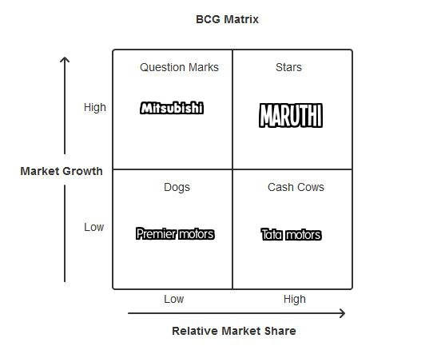
1) Stars (High Market Share / High Market Growth)
A Star represents the ability to produce enormous amount of cash due to their enduring relative market share. At the same time it uses up a large amount due to high growth. Maruti in India falls under this category (Chauhan, 2013). Hence the cash that is spent is relatively equal to the cash brought in to the company. Maruti though being the market leader they have to spend huge amount of money else they will become cash cow.
2) Cash Cows (High Market Share / Low Market Growth)
The cash cows are the controllers of the mature market. They authenticate a return on assets higher than the market growth, there by giving rise to more cash (Virani, 2013). Tata motors in India have these characteristics as they have the high market share but low growth rate. This makes them to reduce the profit level. To improve the profit Tata motors have to invest in the latest technologies.

3) Question Marks (Low Market Share / High Market Growth)
Question marks results due to faster growth of products and due to this reason they consume huge total of cash, but due to their less market share they won’t produce much cash. The end result is large net cash consumption. Mitsubishi falls under this category. Question mark can increase the share in the market and thus can be the star, thus finally a cash cow as the market growth slows(Mitsubishi motors, 2012). If they cannot become the leader, then there are chances for them to become a dog when the market growth turns down. It needs to be observed cautiously to establish them to be worth the investment, which can develop the market share.

4) Dogs (Low Market Share / Low Market Growth)
Dogs are when the situation where the market share and the growth rate are low and they also do not produce nor consumes huge amount of money. But dogs are said to be a money trap due to the cash, which is engaged in business with less potential (D'costa, 1995). So those who follow similar business become divestiture. Premier motors in India face this situation, as they have to involve themselves in divestiture. Mitsubishi in India has low market share and if their growth rate decreases they can become dogs.

4.0 MARKETING MIX STATEGY
1) Product

The product strategy adopted by Mitsubishi is to develop global products that are both financially sound and environmentally safe. They mainly target on small and medium sized cars and SUV’s, in general automobiles and light trucks. They can focus on improving their core technologies and try to develop a more efficient engine, which give them an edge over their competitors in the market (Mitsubishi motors, 2012). They have recently come up with the new product launch plan in which they have planned to introduce an electric vehicle. Instead of giving importance to start new projects, they can involve in developing the existing assignments and improve them. For example, Indian consumers are price conscious and they like to have so many models to choose from. So Mitsubishi can work on its existing Indian market with the Hindusthan motors to tap the market share and increase its profit. The company can take the initiative of helping such people out. People always prefer high performance cars, without sacrificing safety and interior design (Chapman, 1995).

2) Price

As mentioned earlier they target the premium customers by having premium pricing strategy for their cars. Based on the demand for their cars, the supply should be regulated through comprehensive inventory management. Another strategy would be to reduce the after sales service in markets that are already saturated and mature. The best possible way is to invest in areas where there is a probability of achieving growth and profits. For example, the Mitsubishi Montero was initially a failure, but the upgraded version of the car was released with a price tag of 7.99 Lakh Rupees (Mitsubishi motors, 2012). It was rated extra ordinary with a rating of four on five by ‘Autocar India’, one of the leading magazines in the country. In spite of this the car sales was much less than anticipated mainly because of the high prices. On the other hand, Maruti Suzuki’s A star-Zxi model was released almost at the same time and was awarded a four star rating. It was priced around four Lakh Indian rupees. This car managed to dominate the market and earned profits for the company.

A crucial aspect of operating without inventory is quality control. Quality control involves the removal of defective parts and production of defect free parts. It is essential to maintain a good relationship with all the suppliers of the firm. The Japanese firms are a perfect example in this regard. They ensure that they maintain a very good relationship with their suppliers, throughout the design, development and production of all their cars.

According to Alien and J.G. Hicks, marginal rate of technical substitution is given by the rate at which one factor may be substituted by another keeping the output constant (Rowe, 1977). Prior to the restructuring process adopted by Mitsubishi the rate of technical substitution was 0.15. After the execution of this plan the rate has drastically gone up. Mitsubishi should hire capital and labor until the marginal rate oftechnical substitution reaches the targeted level of output.

3) Place

Mitsubishi Motors operate in Japan, North America and Europe (both Western and Central Europe). Their focus markets are Russia, Ukraine, Middle East, China and India. In India, they aim at expanding their markets as they have newly introduced the SUV’s. They have limited themselves to having branches only in four cities in India, namely, Chennai, Kolkata, Mumbai and the headquarters in Delhi. They have only three showrooms in Delhi, which makes it difficult for people to access. Those who wish to go to the showrooms take a look at the cars and then decide on what to buy, need to travel long distances. This makes it hard especially for people in the nearby states to buy Mitsubishi cars(Mitsubishi Motors, 2012). One of the reasons for having less number of showrooms is the lack of space in central areas for inventories. If proper relations are maintained with their suppliers, the need for inventories is reduced. Thus the production and organization characteristics of the firm should be systematic and make it easy to implement the changes in design as demanded by the customers. The Revitalization Plan announced by Mitsubishi in 2005 stressed on recovering trust and restoring earnings. By doing so, they make maximum efforts to try be on par with Maruti Suzuki.

4) Promotion

Mitsubishi needs to promote its tie-ups in a more positive way to establish itself in the market. In 2010 Mitsubishi came up with a global business plan called as “Step up 2010”(Mitsubishi Motors, 2010).They focused more on the emerging markets, as it would ignite a boom in their profits.People have always loved the smell of new cars. So the idea was to recreate that smell and sensation for the consumers. They successfully did that by creating a scratch and sniff advertisement. This gave the consumers the opportunity to relive the smell of the new car. The impact, engagement and awareness that this advertisement created amongst consumers were shocking. Articles were written in newspapers, websites and other important magazines. Groups were opened on Facebook to talk about the car and the idea of the advertisement. The supply ran out in two weeks. In a market that dropped by 20% Mitsubishi was able to show a profit of 16% after the release of its car, Lancer Evolution.

A deeper analysis into the company’s website shows that it does not provide all the data regarding the cars and also queries from people regarding the cars remain unanswered for long periods of time. Mitsubishi India does not spend much amount on the promotion campaign. Where as the market leader Maruthi spends huge amount on the advertising, research and development. Thus to increase the profitability they have to concentrate on the promotion strategies.

5.0 COMPETITIVE STRATEGIES OF MITSUBISHI
Porter’s generic competitive strategies
The competitive advantage of the firm can be measured by using the Porter’s competitive strategies model. Low cost and Differentiation are the two basic competitive advantage strategies derived by Porter in this model and these two basic competitive advantages combine with the range of the firms that leads to three competitive strategies such as, Cost differentiation, Differentiation, Focus (cost or differentiation) (Porter,1985).
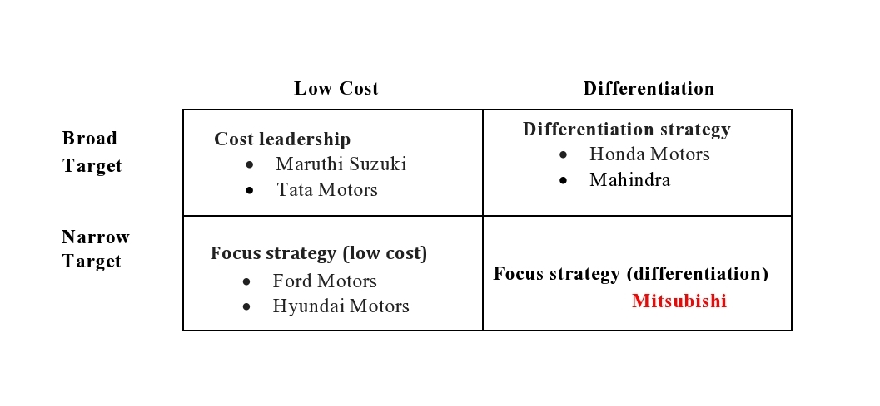
Mitsubishi follows focus differentiation strategy and their scope of market is very narrow.
Mitsubishi focuses on niche market which are being untapped by the competitors. They concentrate more on the SUV’s and premium vehicles. Mitsubishi also concentrates good services to its customers. They position themselves as the premium car sellers in India. So their cars are sold at the higher cost to its customers. These are the competitive advantages of Mitsubishi though there are many competitors following many other strategies Mitsubishi follows the focus strategy by selling only five models in India.

Strategic positioning map
Strategic positioning map assists to establish the positioning in market strategy (Porter,1988). It is otherwise known as perpetual mapping since they are based on the buyer’s perception. Strategic positioning also helps the organization to position their service to lessen the market gap and also to compete with their competitors.

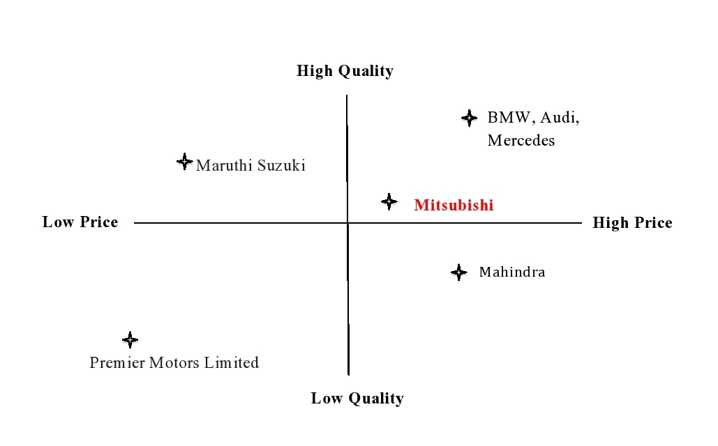
As the sales figure of 2012 shows that Mitsubishi has sold only 2000 units in India. On the other hand, the leaders of the luxury segment sold more than 7500 units of car by the end of 2012 (Choudhury, 2013). Maruti Suzuki being the market leader in India sells high quality products at lower price. Indians are always price conscious, and hence prefer inexpensive Maruti cars. Thus Maruti was able to sell ten million cars in 2012.

Value map

The Value map is used to recognize what their customers perceive about the particular services of an organization. Generally, customers are concerned about getting the best value for their money (Gala, 1990). The services that are offered should satisfy the expectation of the customers. From the company’s point of view this value map is used to track the competitor’s price and the value ofits close competitors.
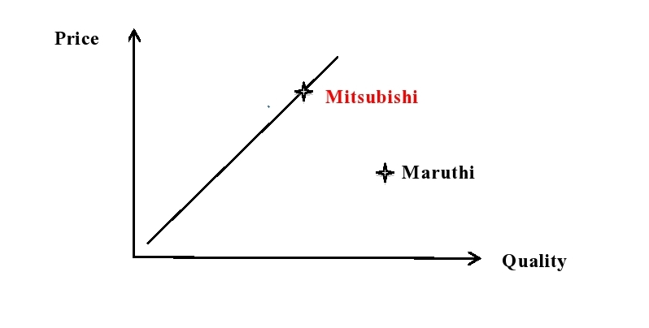
Maruti follows a very competitive pricing strategy where as the Mitsubishi follows premium pricing. Maruti also provides quality products, turning out to be a reason for Maruti to be the market leader. But in case of Mitsubishi, people feel that it is really high priced and there is no resale value. Indians prefer to buy cars that have a good resale value. Compared to Mitsubishi Maruti has a better resale value. This gives Maruti a better value for money than Mitsubishi.

Porter’s five forces model ( Appendix A)

Threat of new entrants to a market

There is always easy entry and easy exit due to automobile industries face perfect competition (Besanko. et al, 2010). Mitsubishi Motors India cannot keep away from new entrants. But as they are price takers in this industry, the risk from new competitor (entrants) is very high and their market share will be diluted to other competitors.

Bargaining power of suppliers

Mitsubishi depends on the Hindustan motors and home country for its supplies. They procure all the materials needed for the manufacturing of cars from Japan and some materials from the local market through the Hindustan motors as they have the Joint venture with them (Chheda, 2010).Mitsubishi has sold only 2000 units in India so the bargaining power of the supplier will be high when compared to its competitors. As the bargaining power of suppliers is high, this could be the reason for selling the products at a high price.
Bargaining power of customers
Customers are the major players in the business. Customers have so many options and various brands of cars at the same price. So the bargaining powers of the customers are really high (Schoenherr, 2008). Therefore, Mitsubishi should satisfy its customers with its products and make them brand loyal to become the market leader, else they will surely face tough situation.

Threat from substitutes

Mitsubishi positions itself as the premium product provider like the BMW, Audi, and Mercedes. There are many cheap substitutes in the market like the Maruti, Tata, and Hyundai. So Mitsubishi should worry about the cheap substitutes or they must provide excellent value for the money by providing high-class quality product and services(Gupta, 1983).

Degree of competitive rivalry

As it’s a perfect competition industry there are so many product providers selling similar cars and SUV’s. Mitsubishi must focus on the differentiation strategy so that they will be unique from its competitors(Patrick Tomich, 1995). They should target the untapped market in order to avoid competition.

6.0 MACRO ENVIRONMENTAL ANAYLSIS
In examining the macro environment of Mitsubishi Motors India, it is critical to make out the major aspects, which influence the industry while the company enters in to other nations. With macro environmental analysis the factors such as political, economic, social, technological, legal and environmental assist us to understand the host market condition, opportunity, development and decision-making(Alon, 2006).

Political Factors

The Government has liberalized the laws and regulations for foreign investment and the import of technology, which has benefited the automobile sector. The industry has adopted global standards. But automobile industries in India face immense taxation on business because of the increased regulation(Srinivasan , 2012).

Economic Factors

It relates to the exchange rates and global economic growth rates that are predominant in the company. Factors like recession and inflation problems can change the company’s future plans and its present operation(Ruff, 2006).The introduction of GST (Goods and Service Tax) has a demoralizing result on Mitsubishi Motors due to their sales and turnover figures. It shows that customers postpone their purchases, which in turn creates problems for Mitsubishi car retailing companies.

Social Factors

One of the main problems that Mitsubishi Motors in India is facing is the shift in the customer’s first choice from expensive cars with huge carbon emission to a fuel-efficient small car. This is because of the increased price of oil and also the government provides tax incentives to those who buy fuel-efficient cars. This shift in preference of customer has resulted Mitsubishi, as their downturn for the performance. Hence, Mitsubishi has to develop products, which is fuel-efficient (Alon, 2006).

Technological Factors

Mitsubishi’s competitors like Maruti and Toyota have captured the automobile market through the implementation of various advanced technology in to its product strategy and hence met the public’s needs of fuel-efficient cars with low carbon emission in to the atmosphere(Ruff, 2006). This technological change was not implemented initially by Mitsubishi Motors India.

Environmental Factors

Increased pollution has been resulted due to high carbon emission from big cars, which causes problems like air pollution. So Mitsubishi has to come out with the car that doesn’t harm the environment. So hybrid cars have to be developed to solve this issue. In India, taxation varies depending on the emission rate. So to reduce the tax they have to develop the hybrid cars with good fuel-efficiency.

7.0 SWOT ANALYSIS
SWOT is a strategic setting tool used to assess the business Strengths, Weakness, Opportunities and Threats. It also helps in understanding the issues that are favorable and unfavorable for achieving the target(Mitsubishi Motors Corporation, 2013). SWOT analysis of Mitsubishi Motors helps them in scanning their main business structure and operations, past records and manufactured goods, and also provides review of its revenue and strategies. Thus SWOT analysis of Mitsubishi Motors is a necessary source for company’s information.

Strength:

Mitsubishi Motors in India is a popular brand in collaboration with Hindustan Motors with attracts the people with excellent advertisements. Other strengths include reduced labor costs, steadiness in revenue systems and strong worldwide variety.
Weakness:

Mitsubishi Motors India has only 5 varieties of cars in India. So this makes them weak in their R & D and their employees are inefficient. Also the technology that they are implementing in India is not effective for them to capture Indian market.
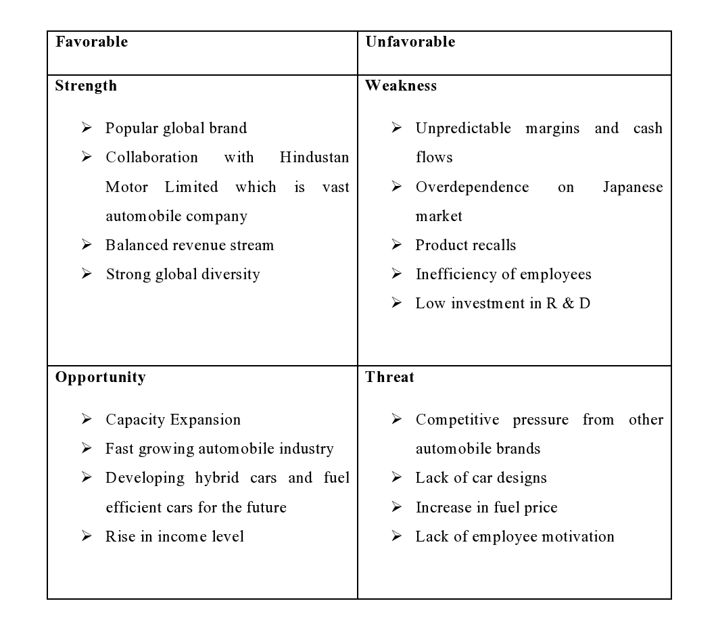

Opportunity:

Once they develop more sophisticated technology in Indian market they can attract large number of peoples in different cities in India. Also they can improve the infrastructure, develop hybrid cars and also fuel efficient cars in Indian Market.

Threat:
Major threat for Mitsubishi Motors India is that rise in petrol price in India, so that their cars demand are reducing due to their cars having low mileage. Also competitors launching fuel-efficient cars with low budgets are a threat for them. Rise in interest rate is also another threat that Mitsubishi is facing.

8.0 ISSUE IDENTIFICATION
1) Product
The main issue with the Mitsubishi is the product line they have in India. Lancer, Pajero, Cedia, Montero and Outlander are the cars that are available in India. Mitsubishi Indian users have limited options so they wish that there were so many models available for them to choose. Where as in the case of the market leader the Maruti Suzuki motors India have sixteen models for the customers to choose. The Mitsubishi pricing is premium as it starts from Rs 9,50,000 and its top end model is available at Rs 52,00,000. Where as in the case of Maruti Suzuki they have cars starting from just Rs 2,50,000 till Rs 25,00,000. (Car wale, 2013) India is a developing country and the people normally prefer economical cars.
Ansoff Growth / Diversification Strategy
The Ansoff growth matrix is a planning tool to measure the performance of the product and market. The output of this matrix is the set of directions for the business strategy (Riley, 2012).
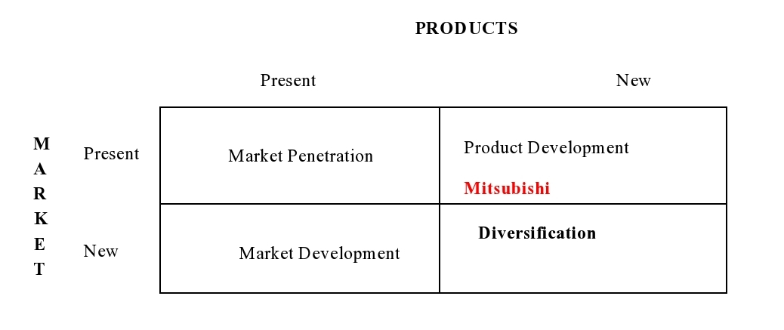
Mitsubishi should engage itself in the process of developing the new products that are suitable for the Indian roads and Indian consumer’s price budget. Like what the giant German engineering company Volkswagen did, though they were selling premium cars they developed a budget car in India in the name of Polo. Mitsubishi can also follow this strategy and develop new products in India.

Blue ocean strategy

The market can be broadly classified into two types (Chan Kim &Mauborgne 2004)namely,(Appendix B)
- Red ocean: All industries in existence today
- Blue ocean:All industries not in existence today
Mitsubishi must concentrate on ways to tap the new market space, demand creation and opportunity for high profitable growth.Due to the impact of Globalization the competition has become fierce. Hence, the market share is shared among all the existing players. So Mitsubishi should target the blue ocean and create new market and demand so that they can easily become successful in the future.

Product design and branding
Mitsubishi should offer a wide range of innovative and quality cars to attract new customers and retain the loyal customers. They should develop a design that suits the Indian customers, as the taste and preference of customer’s changes from one country to another. This is the reason why Ford Endeavor failed in the Indian market; people did not like its model (Khan, 2012). So much importance should be given on the product design that Mitsubishi is going to offer.
Branding is very important in a sense that it helps the customers to identify a particular product (Thomas C. O'Guinn, 2011). To succeed in branding Mitsubishi should understand the needs and wants of the customers and their prospects. Brand helps to reside within the heart and the minds if the customers (M.Murphy, 2008).Increasing the brand value is really important, as it is invaluable as the battle for customers intensifies day by day. Brand acts as a source of promise that a particular company provides. Mitsubishi should improve the branding strategy, like the premium carmakers such as the BMW, Audi and Mercedes. They have huge success in the Indian market as they have the advantage of high brand value.
In order to create a good brand name and to differentiate from others Mitsubishi must follow the three R’s of branding like Wellesley Hills Group (CrostonWellesley Hills Group). They are,
a) Reach – Mitsubishi should identify its correct target market and then work on the process of reaching them. As Mitsubishi positions itself in the premium car segment they should target the youth population that is booming in India. They should reach them through advertisements and promotion campaigns.
b) Reputation – Mitsubishi should work on improving its reputation day by day from their past successes. Having a good reputation will help to gain a good brand image in the society. So Mitsubishi should have good value system.
c) Recognition – Mitsubishi should manage to gain recognition from its buyers, leading to increase in sales and increase in the profit. People should be able to recognize Mitsubishi easily by their logo, good value and quality products.

2) Promotion
Advertising and R & D
Mitsubishi in India has not focused on advertisement and sales promotion. It has affected their recognition, because advertising and sales promotion helps to attract more people and to gain competitive advantage (Pindyck&Rubinfeld, 2009).
Maruti spent about Rs 2580 million for its advertisement and Research and development (Maruti, 2012) whereas the Mitsubishi has never spent on its products in India (Tiwary, 2013). People had to always walk into the showroom to know about the product. Advertising is very important when a new product is launched as it creates interest in the minds of the customers. Mitsubishi should also invest in the R & D to bring new products to the Indian market.
Push or Pull strategies
Between these two marketing theories the Push strategy suits the best for Mitsubishi, because the sales are very less in India. A “push” promotional strategy makes use of a company's sales force and trade promotion activities to create consumer demand for a product. The advertisements and various offers are provided to customers to push the products(Hair, McDaniel & Lamb, 2008). This strategy also avoids the links in between to reach the final customers. Thus by following this strategy the company can increase sales and profit.

Developing a good promotion and marketing strategy

Promotion is a main ingredient of the marketing mix. It is concerned with the kind of communication that occurs betweenthe producer and the consumer, if it is one way or two ways. Determining a marketing strategy that involves communication is one of the fundamental roles of a marketing manager. This process involves key decisions like knowing the consumer is, ways to contact them, and details regarding the message to be communicated. Solutions to such issues are given by adopting a three-stage process, which is equally relevant to all the elements present in the marketing mix.

1) Segmentation

Segmentation draws in details about separating all the potential customers into various discrete groups, in cases where the rate of success of a communication message needs to be increased. This information can be acquired in a number of ways, right from commissioning a specialist market research agency to questionnaires on scrutinizing the sales patterns or interactions with the social media(Kamakura & Wedel, 2000).
2) Targeting

Targeting involves the process of communicating with the right segment and ensuring the best possible response rate(Freeman, 1992).The main reason behind targeting is advertising.

Methods of marketing communication

The various ways to reach customers are mainly throughadvertising. The other available measures are through sales promotion, where the products are promoted via sales executives;public relations,personal selling,direct marketing, and digitalmarketing.

Deciding on which media to use

In India advertising through the television is considered to be the most effective means of advertising; especially when the cricket matches are telecasted (Subramanian, 2011).More than 122 million fans watch cricket on TV. Mitsubishi can concentrate on advertisements. They should also invest in digital marketing, as there is a considerable amount of the population that uses the Internet. They should have a detailed website that tells everything about the particular car.
Integrated marketing communications

After choosing the right media to advertise it is very important to use the integrated approach. It is the process by which all the media, work towards the same objective. Like using similar messages, look and feel throughout all the media, an integrated approach can dramatically increase the effectiveness of any campaign and will help create your brand image(Kitchen &Pelsmacker, 2004).

3) Positioning

Positioning is the process of developing an image of the company or product. It can be effectively done through proper branding. It also includes competition so Mitsubishi should try to be unique than its other competitors (Piercy, Saunders, Nicaulaud&Hooley, 2008). Thus in short we can say that Mitsubishi should know the audience, target them efficiently and then position them so that they are benefited from it.
9.0 CONCLUSION
Mitsubishi in India has only a market share of 2.2% in Indian market as they target the premium customers. In order to attract customers from the Indian market they have to bring up more new models that are suitable for the middle class people in India. They must concentrate on the promotion strategy to attract new customers. The Majority of Indian population consists of average income group who are interested in low price and quality products. Mitsubishi is targeting premium customers they have to compete with BMW, Mercedes & Audi by increasing their brand value else they need to develop economical products that attract the Indian consumers. The best option is to follow the market leader Maruti to increase the sales and the revenue.

Reference

Alon, I. (2006). Market conditions favoring master international franchise. Multinational Business Review, 14(2), 67-82.

Besanko, D., Dranove, D. and Shanley, M. 2010, ‘Industry Analysis’, Economics of strategy, 5th edn, Ch 12, pp. 327-356, John Wiley Sons, New York.

Carwale. (2013). Retrieved from http://www.carwale.com/mitsubishi-cars/

Chan Kim , W &Mauborgne, R Sep 2004, ‘Blue ocean strategy From Theory to Practice’, California management review, vol. 47, no. 3, pp. 105-121

Chheda, D. (2010, July 14). Mitsubishi Motors To Buy Stake In Hindustan Motors. Retrieved from Dealcurry.com: http://www.dealcurry.com/20100714-Mitsubishi-Motors-To-Buy-

Choudhury, A. (2013). The wall of street journal.BMW India Posts Flat 2012 Sales at 9,375 Vehicles, Retrieved from http://online.wsj.com/article/SB10001424127887323482504578230742017120934.html

Chauhan, P. (2013, Jan 9). Marutisuzuki's market share slips to a new low, company officials blame violent labour troubles for it. The Economic times, Retrieved fromhttp://articles.economictimes.indiatimes.com/2013-01-09/news/36237645_1_mayank-pareek-petrol-cars-manesar-plants

Croston, Robert, ‘The Three R’s of Service Branding: Reach, Recognition and Reputation’, Wellesley Hills Group, http://www.whillsgroup.com/insights/articles/the-three-r2019s-of-service-branding-reach-recognition-and-reputation

D'costa, A. P. (1995). The restructuring of the Indian automobile industry: Indian state and Japanese capital. World Development, 23 (3), 485-502.

Drejer, A. (2002). Strategic management and core competencies: Theory and application. Greenwood Publishing Group.

Freeman, K. M. (1992). Target marketing: The Logic Of It All. Journal of Consumer Marketing, 9 (3), 15-18.

Gale, B. (1990, Mar 16). The value map. Retrieved from http://www.cval.com/valuemap.htm

Gottschalk, B. (Ed.). (2007). Mastering Automotive Challenges.Kogan

Gupta, A. K. (1983). Industry Self-Regulation: An Economic, Organizational, and Political Analysis . Academy of Management Review , 8 (3).

Hair F.J, McDaniel C. D, &Lamb,W.C. (n.d.). (2008) Essential of marketing.

Kamakura, W., & Wedel, M. (2000). Market segmentation: conceptual and methodological foundation.

Kanter, R. M. (1990). How to compete. Harvard Business Review, 68(4), 7-8.

Khan, F. (2012, Dec 18). What went wrong with ford india in 2012?

Kitchen, P. J., &Pelsmacker, P. D. (2004). Integrated marketing communications.

Maruti, S. (2012). Profit & loss – maruti Suzuki india ltd. The Economic times. Retrieved from http://economictimes.indiatimes.com/maruti-suzuki-india-ltd/profitandlose/companyid-11890.cms

Mitsubishi motors corporation - swot, strategy and corporate finance report. (2013, January Retrieved from http://www.marketresearch.com/MarketLine-v3883/Mitsubishi-Motors-Corporation-SWOT-Strategy-7383031/view-stat/

Motors, M. (2010). “Step Up 2010,” Mitsubishi Motors’ New Mid-Term Business Plan, Kicked Off. Retrieved from Mitsubishi Motors: http://www.mitsubishi-motors.com/corporate/ir/share/pdf/e/fact_2008_02.pdf

Mukherjee, A. (2000). The Índian automobile industry: speeding into the future?.Actes du GERPISA, (28), 35.

Murphy, M.J. (2008, 06 23). Branding: A key marketing tool.

Patrick Tomich, T. (1995). Transforming agrarian economies: Opportunities seized, opportunities missed.

Piercy F.N, Saunders A.J, Nicaulaud, B, & Hooley, J.G. (2008). Marketing strategy and competitive positioning.

Pindyck , Robert S. &Rubinfeld, Daniel L 2009, ‘Microeconomics’,7th edn, Ch 11, pp. 391-429

Porter, M. (1985). Competitive advantage: Creating and sustaining superior performance. (1st ed., Vol. 01, pp. 11-15). New york: The free press.

Porter, M. (1988). Competitive strategy: Techniques for analyzing industries and competitors. (1st ed., Vol. 01, pp. 152-156). New york: The free press.

Porter, Michael E 1980, ‘Structure Analysis of Industries’, Competitive strategy : techniques for analyzing industries and competitors , Ch 1, pp. 3-33

Riley, J. (2012, Oct 24). Ansoff matrix. Retrieved from http://www.tutor2u.net/business/strategy/ansoff_matrix.htm

Ruff, F. (2006). Corporate foresight: integrating the future business environment into innovation and strategy. International Journal of Technology Management , 34 (3).

Schoenherr, T. (2008). Factors moderating the influence of bargaining power on performance in supply chain management. Michigan State University, Supply Chain Management.

Srinivasan, R., & , (2012). Services marketing : the indian context. (3rd ed.). New Delhi

Subramanian, S. (2011, Mar 30). India pakistan have contentious rivalry in cricket matches. The National, Retrieved from http://www.thenational.ae/news/world/south-asia/india-and-pakistan-have-contentious-rivalry-in-cricket-matches

Thomas C. O'Guinn, C. T. (2011). Advertising and Integrated Brand Promotion (6 ed.). South-Western Cengage Learning.

Tiwari, S. (2013, Apr 30). The financial express .Taxman queries royalty paid by Maruti to Suzuki. Retrieved from http://www.financialexpress.com/news/taxman-queries-royalty-paid-by-maruti-to-suzuki/1109475/0

Virani, V. (2013). Sustainable Growth Rate: Refining a Measure – a Case Study of Tata Motors and Maruti Suzuki. Indian Journal Of Applied Research, 3 (4), 317-319.

Appendix-A

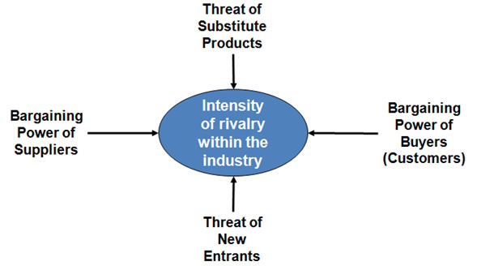

Appendix-B

