Hello,
I am writing my thesis and I worry that i will run out of time. I am struggling with method, results, and discussion parts; therefore, I will really appreciate it if you help me with the first parts. I want you to write the introduction of about two pages and the literature review parts of two or three pages about fundus camera. In the literature review I want you to talk briefly about the development of fundus camera since it was found until now. I also need to write in details about Maxwellian Viewing system. These are the heading I need you to write about
1- Introduction
2- Literature review on fundus camera
3- Maxwellian Viewing system
- Retinal Illuminance
-Focus
-Field of View
3- Advantages of Maxwellian Viewing
4- Limitation of the Maxwellian View

These are the reference at you can use and if you can access more please do so.
Introduction and literature review on fundus camera
http://www.ncbi.nlm.nih.gov/pmc/articles/PMC3521302/pdf/3264.pdf
http://www.ncbi.nlm.nih.gov/pmc/articles/PMC3131209/pdf/nihms301360.pdf
http://research.ijcaonline.org/volume68/number8/pxc3886962.pdf
http://www.ncbi.nlm.nih.gov/pmc/articles/PMC2845292/
Retina (I can send it to by email)
A Brief History of the Ophthalmoscope (I can send it to by email)
Maxwellian http://inis.jinr.ru/sl/vol2/Physics/_%D0%9E%D0%BF%D1%82%D0%B8%D0%BA%D0%B0,%D0%AD%D0%BB%D0%B5%D0%BA%D1%82%D1%80%D0%BE%D0%B4%D0%B8%D0%BD%D0%B0%D0%BC%D0%B8%D0%BA%D0%B0/HANDBOOK_of_OPTICS/HANDBOOK_of_OPTICS/v1ch28.pdf
http://www.jstor.org/discover/10.2307/1417947?uid=3738744&uid=2&uid=4&sid=21104621370333
http://nozdr.ru/data/media/biblioteka/kolxo3/P_Physics/PE_Electromagnetism/PEo_Optics/Bass%20M.%20(ed.)%20Handbook%20of%20Optics%20Vol.%203%20(3ed.,%20MGH,%202009)(ISBN%200071498915)(O)(854s)_PEo_.pdf#page=210
http://psy2.ucsd.edu/~dmacleod/publications/97BeerMacLeodMiller2005.pdf
A Limitation of the 'Maxwellian View (I can send it to by email)
Calibrating Maxwellian-view optical systems (I can send it to by email)
The following page is what I have written about Maxwellian you can continue on that.

2. Method
There are two well-known viewing systems in vision research Newtonian viewing and maxwellian viewing systems. In Newtonian viewing method an image of a target is generally formed on the retina without and additional optical element to the eye (Figure.55). The retinal illuminance of an object in Newtonian view depends on the luminous intensity of the target, and the size of the pupil of the eye. This dependency results in some major limitations of Newtonian view. As the retinal illuminance is determined by the luminous intensity of the target, obtaining a uniform 20˚ field using a bulb (a 60-W), which is capable of producing 120,000-td field, requires the bulb to be placed 17 inches from the observer’s eye, which not all observers can accommodate. Otherwise, larger light sources need to be used. The second limitation is that controlling the variations in pupil size is not plain (Burns et all, 1994).

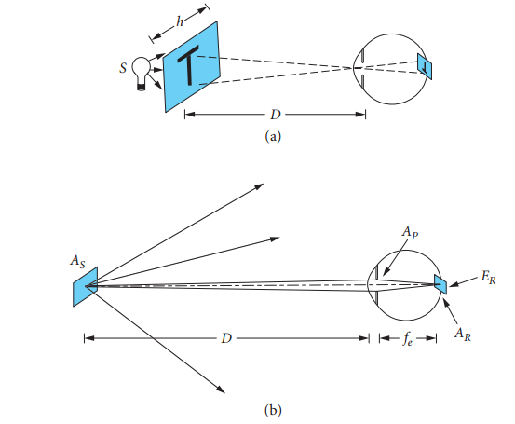

Fig. 55: (a) in or Newtonian viewing the eyes optics are used to image a target onto the retina. (b) Computation of the retinal illuminance in free-viewing. As the area of the source, D the distance between the source and the eye, Ap the area of the pupil, fe the optical focal length of the eye, AR the area of the image of the source on the retina, and ER the retinal illuminance (Burns et all, 1994).
2.1 Maxwellian Viewing system

2.2 Advantages of Maxwellian Viewing

2.3 Limitation of the Maxwellian View

