How do rich pictures and use cases provide better understanding of the system requirements to you as the analyst, and also to the client and the software developers? (In the region of 2000 words)

In answering this question you should:
i) draw examples from the analysis you have carried out in the following rich picture and use case
ii) show how the tools are useful in talking to non-technical people (clients) about the
requirements
iii) show how the tools are a useful starting point for talking to the technical staff (software
developers) about how to implement the system

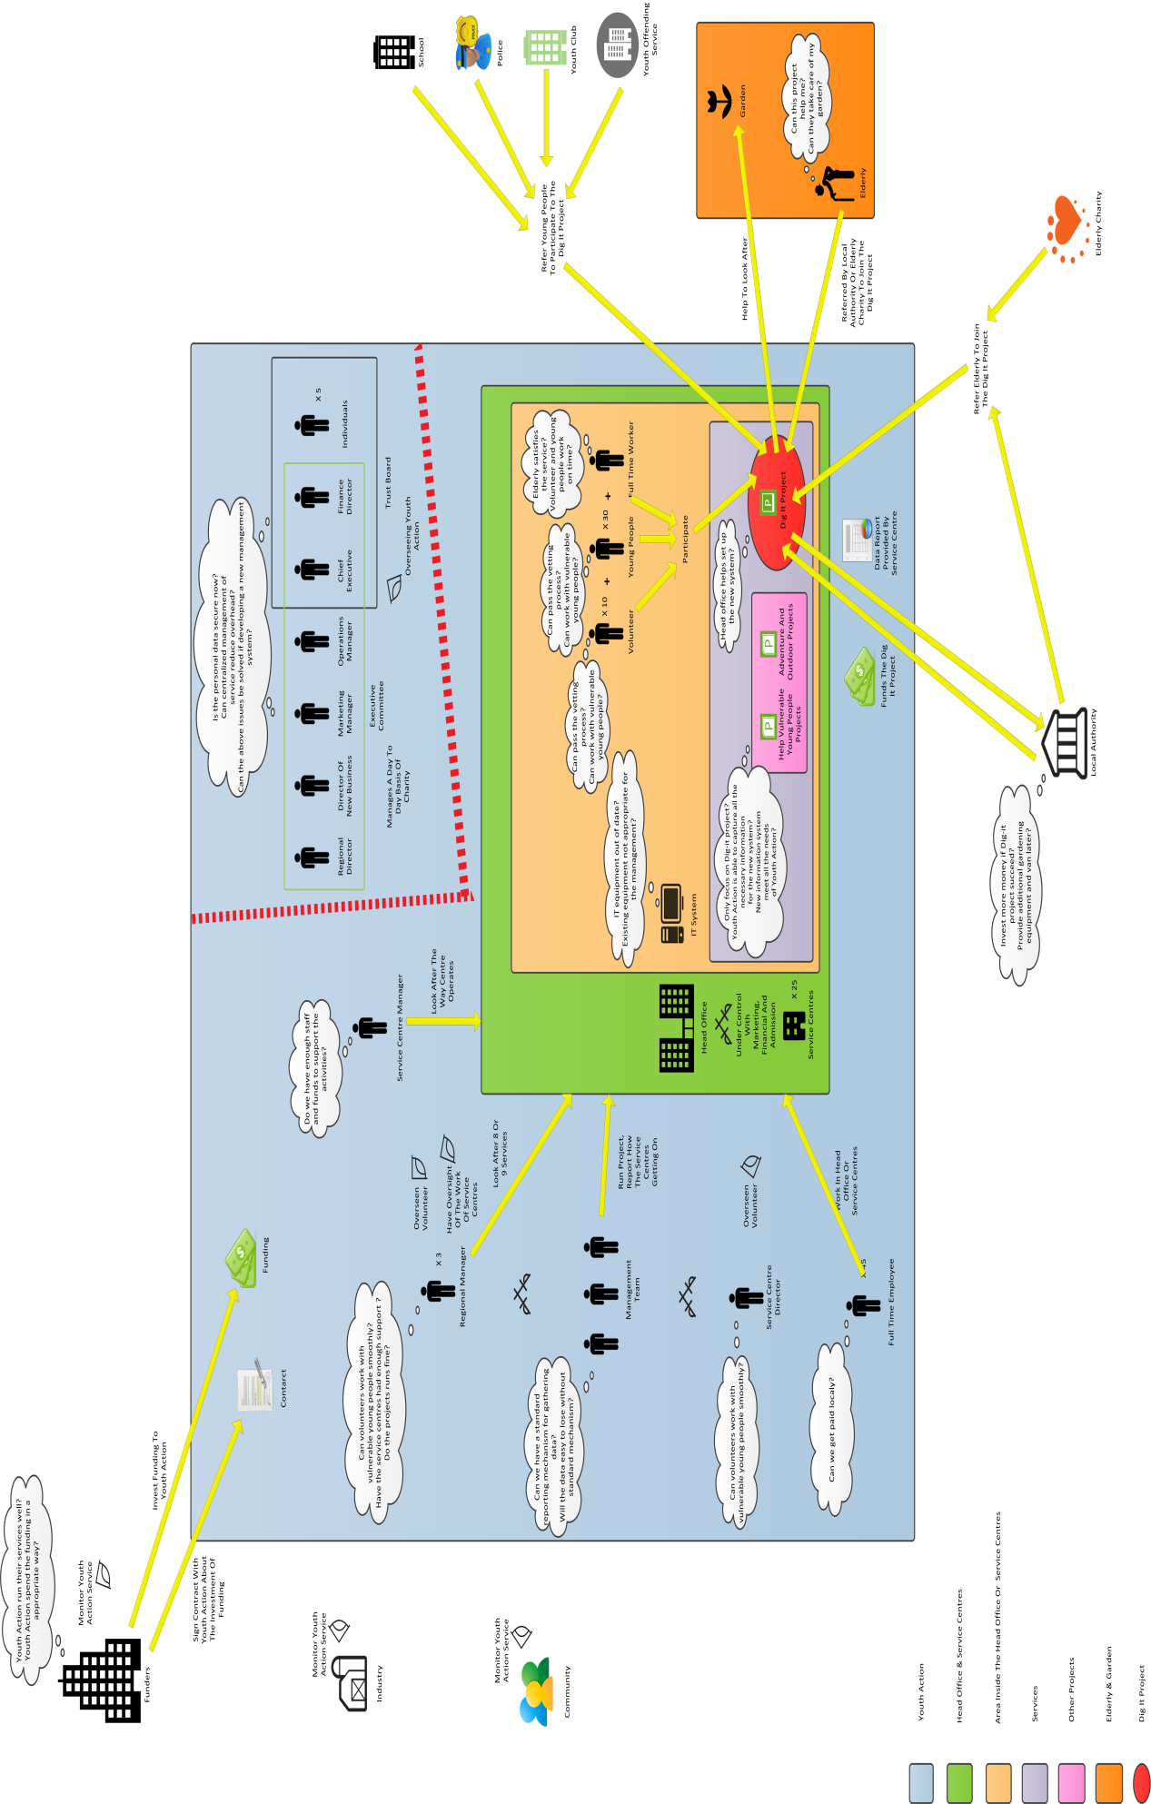
YouthAction Case Study
You have been asked to develop a system and some applications to help manage parts of a charity,
YouthAction. The charity is coming under pressure from their funders to demonstrate value for money
and are keen to collect suitable data demonstrate how well each service it offers is running.
YouthAction is a charity based in the south east of England that supports young people through a
number of funded projects. Their main service is to provide adventure and outdoor projects or projects
which help vulnerable young person to improve their life in some way. Many of the young people are
from deprived backgrounds and many are at risk of committing crime.
YouthAction has 45 full time employees working for it, either at its head office or at its service centres.
Many of the local projects are run by volunteers overseen by one of YouthActions’s regional
managers or service centre directors. There are three regional managers in total. Most service
centres have a paid fulltime worker (normally known as the service centre director) dedicated to
managing it.
YouthAction have something like 25 different service centres throughout the South of England. Each
regional manager looks after about 8 or 9 different services each.
Service Centres
A service is made up of one or more projects based at one location. For example, a YouthAction
Service Centre based in an old school in East London, runs a youth club, a series educational support
classes, a drop-in centre, a teenage wellbeing clinic and an employment help desk. Each of these
projects are funded separately. The centre is open 7 days a week and other youth groups use its
premises to run their own activities. The centre is part funded by the local authority, as well as through
charitable donations. Another centre, in a more rural part of the world, only runs one project, teaching
young people how to become motor mechanics. This project is funded by a major car manufacturer
based in the area through the companies social enterprise fund.
In the past each service centre has run in a fairly autonomous fashion. The service centre manager
would normally be responsible for looking after the way the centre operates, the employment of staff
and raising funds to support the activities. Regional managers have oversight of the work.
YouthAction have provided support to all centres with marketing, financial management,
administration, and a range of other activities as requested by centres. Any finance to support a
centre is paid to the charity centrally and money is then allocated to the centre and project as
required. All salaries are paid centrally. Service centres will manage any volunteers working on
projects locally. However all volunteers are expected to be put through a vetting process with the
Head Office as many of the people volunteering to work with YouthAction will be working with
vulnerable young people. This checking process does not always happen as it should.
The funding of each project will be subject to a contract agreed by YouthAction and the funder. The
contract outlines the length of the project, the value of the funding and any constraints on how the
funding can be used. A service centre might have 5 or 6 different contracts in place to fund all the
activity in the centre.
Management of YouthAction
The YouthAction Trust Board, is the group overseeing the charity and the Executive Committee
manages the charity on a day to day basis. The Trust Board is made up of the Chief Executive, the Finance Director, and five individuals drawn from the community and industry. The day to day running
of the charity is managed by the Executive Committee made up of the Chief Executive, the Finance
Director, the Operations Manager, the Marketing Manager and the Director of New Business. In
addition, the Regional Directors are asked to be part of the group when necessary.
The charity has invested in a number of central IT systems in areas such as finance and marketing.
These systems have been purchased in a piecemeal way and are not integrated.
Each service centre will have its own management team to run projects at its centre, normally chaired
by the centre director or regional manager. The normal practice is for service centres to report
quarterly on how they are getting on. There is no standard reporting mechanism for gathering the
data.
Review of Services and projects
The Trust Board and Executive Committee have been carrying out a major review of the way the
charity operates. It is concerned that by having each of the services and projects running
autonomously that there is a significant overhead to the charity which could be reduced if much of the
management of services was centralised. It is particularly concerned about the investment in IT at a
service centre level. It also has significant concerns about the way centres and projects are holding
personal data. The charity has recently been reprimanded for failing to keep personal data secure
and, in some places, holding incorrect data.
One of the conclusions of this review is that the charity should invest in the purchase or development
of a management information system.
IT Services
Each service centre have made their own investment in IT, systems for managing projects, and so on.
A recent survey of IT being used in centres has shown that the majority of the data used by centres is
held in spreadsheets. In several places, centres are connected to systems operated by a third party.
These might be local authorities, health services, or other charities, as required by the needs of each
individual project. It is common for people working on a project are entering the same data into 2 or 3
different systems, depending upon the structure of the project and who the funder is.
The IT survey also indicated that much of the IT equipment used by services is out of date and would
not be appropriate for a modern management information system.
The Dig-it Project
A service centre in south east London as recently received funding to start a new project called Dig-It.
Dig-It, is funded by the local authority in the area. The project is to take young people who are seen at
risk of offending and involve them in helping to look after the gardens of the elderly. A young person
can be referred to the project from a number of different sources. Typically these would be by a
school, the youth offending service, the police, or youth clubs. Elderly people with a need for help with
their gardens are referred to Dig-It also from a number of different sources, e.g. the local authority or
a charities working with the elderly.
There is one full time worker managing the project and 10 volunteers. There are about 30 young
people involved in the project at any one time. The young people are arranged in groups of three or
four and each group is led by one of the volunteers. The young people are assigned to working with
one volunteer as they join the project. Tim, the full time worker for Dig-it, works out a rota of
volunteers (they normally give up one morning or afternoon to working on the project) and matches
the groups to the requests for working in people’s gardens. After a group has worked in someone’s garden, Tim will phone or call round to the person to make sure they are happy. Dig-It already have
quite a long list elderly people who have their gardens looked after by the project.
The local authority see this as potentially a very successful project, bringing together the needs of the
elderly and helping to rehabilitate young people with social problems. If it is successful they would
consider investing more money into the project to allow the employment of another full time worker
and provide additional gardening equipment and a van to transport equipment around. However, they
want to see regular data about how the project is running.
The Dig-It project has asked YouthAction centrally if they can help set up a system to allow them to
record the necessary data for the local authority. They also would like a system that can manage the
project with the allocation of young people to teams, sending teams to support elderly people and so
on.
YouthAction see this as an opportunity to start developing the management information system.
However, they are mindful of the fact that Dig-It is just one of many projects and each of the services
have different needs and requirements. Nonetheless, they have agreed to using Dig-It as a prototype
to developing a system which will support both Dig-It’s requirements and identify the requirements of
the management information system for the charity centrally.There have been some worries from
managers and workers from other projects that by focusing on Dig-It, YouthAction might not capture
all the necessary information to build an information system to meet all the needs of charity.

