DISCCUSSION:
1. How do the external and internal environments in which financial planning
occurs differ?
A client's success in financial planning is influenced by both internal and external environmental
factors. Internal environmental forces include a client’s current and projected financial
situation, tolerance for risk, discipline regarding savings and investments, consumption
patterns, and financial goals. The external environment is made up of a variety of external
factors, or subenvironments, that are broad in scope but have at least some direct or indirect
influence on the financial planning process. The external environment includes economic,
legal, social, technological, political, and taxation factors. For the financial planner, the purpose
of studying and monitoring the external environment is to scan for opportunities and
threats that may relate to particular clients and their particular financial goals. The financial
planner may forecast external trends (or use experts to forecast trends) to help achieve client
goals and avoid external risks.
2. What are some examples of how each external environmental factor might affect
clients from different economic levels?
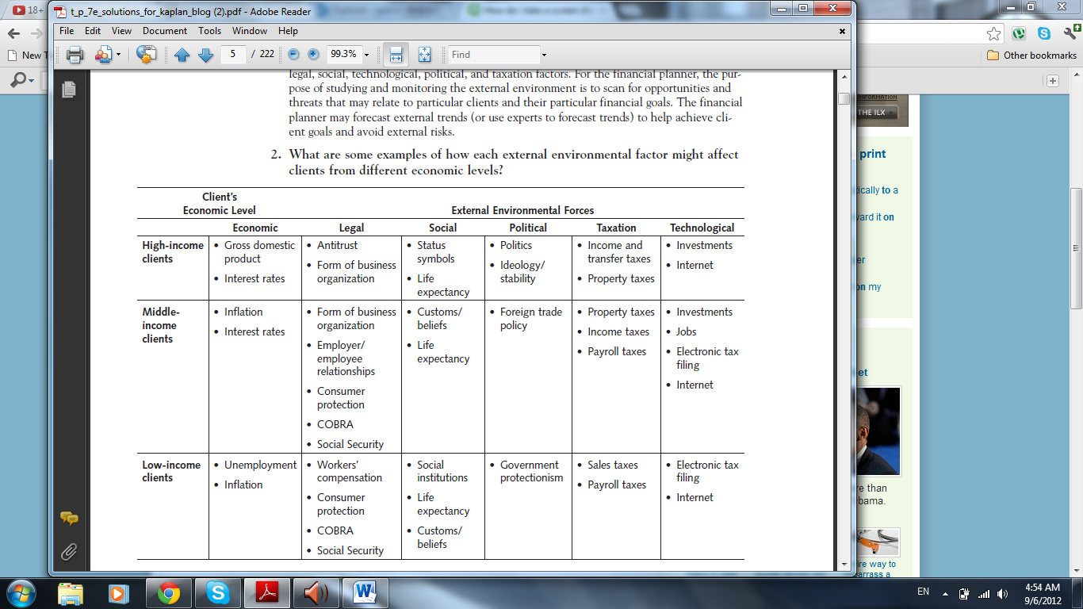
3. Why is external environmental analysis so important?
External environmental analysis is important for a variety of reasons.
■■ External trends and particular events play a significant role in effecting change in the
world and in the behavior of individuals.
■■ C hanges in external forces affect beliefs, economics, unemployment, inflation, and a society’s
well-being.
■■ The external environment shapes the way people live, work, spend, save, and think.
4. How is the external environment analyzed?
External environmental analysis is the process of identifying and monitoring the environment
in which a client exists and the opportunities and threats that are present. In performing
the external environmental analysis, the financial planner must determine the relevance
of one or more external environmental factors for a particular client. The relevance of such
factors may be dependent on the client’s age, goals, net worth, or income. The regular observation
and monitoring of the external environment by the financial planner is essential to
providing high-quality financial planning services. Financial planners may study the external
environment formally or informally. Formal study usually includes university-level courses in
economics, taxation, political science, sociology, and the legal environment. The external
environment may be studied informally by using a variety of sources, such as general economic
and business periodicals, books, academic and professional journals, newspapers, and
government statistical studies, and by obtaining environmental briefings from various information
providers. Financial planners also take continuing professional education courses to
stay abreast of the ever-changing external environment.
5. Why is the economic environment so important to financial planning?
Of all the external environments, the economic environment has the most direct influence
on personal financial planning. The economic environment includes many factors, such
as gross domestic product, inflation rates, interest rates, trade payments, consumer income/
debt/spending, unemployment, population age, and the index of leading economic indicators.
Many of these factors, namely interest rates, inflation, unemployment, and gross domestic
product, play a key role in real investment returns and, therefore, in the accomplishment
of financial goals. Professional financial planners must understand the economic environment
to better forecast the economic future. By identifying the opportunities and risks that
lie ahead, planners can help clients adapt to that future. The planner needs an understanding
of the current economy’s general condition, the current interest rate environment, the
current rate of inflation, and recent changes in monetary and fiscal policy. It is essential for
a planner to have the ability to anticipate each element’s behavior and its potential effect
on a client’s financial plan.
10. How do interest rates, taxes, and inflation affect areas of financial planning?
The interest rate is the price of money. Decreases in interest rates are often followed by periods
of economic expansion, whereas increases are generally followed by economic contractions.
Investment returns and purchasing power are two areas that are affected by the rise
and fall of interest rates. Taxation, in its myriad forms, leaves the taxpayer with less disposable
income. In that sense, all taxes—income taxes, estate transfer taxes, payroll taxes, property
taxes, and sales taxes—have a dampening effect on consumer spending and consumption.
Inflation is another important element affecting the economic environment. Inflation
is an increase in price level. These are three of the main factors affecting financial planning
in the external environment that must be recognized by the financial planner.
11. What are the components of the business cycle, and how do they affect the
economy?
The business cycle consists of two general phases, expansion and contraction, and two
points, peak and trough. The expansion phase leads to the peak point. During the expansion
phase, business sales rise, gross domestic product (GDP) grows, and unemployment
declines. The peak point appears at the end of the expansion phase when most businesses
are operating at full capacity and GDP is increasing rapidly. The peak is the point at which
GDP is at its highest and exceeds the long-run average GDP. Usually employment levels
also peak at this point. The contraction phase leads to the trough point. During the contraction
phase, business sales fall, GDP growth falls, and unemployment increases. The trough
point appears at the end of the contraction phase where businesses are generally operating at
their lowest capacity levels. The trough point is characterized by GDP growth at its lowest.
Unemployment is rapidly increasing and finally peaks when sales fall rapidly.
26. How do the external environmental factors—social, technological, political, and
taxation—affect a client’s financial plan?
Financial planners must accurately assess the social environment and forecast the threats
and opportunities that change will bring. Perhaps the most rapidly changing environment
is that of technology. Success will come from keeping a constant vigil on the characteristics
that make up the technological environment. The political environment is especially important
to risk analysis in investments. This analysis becomes more important as we move to a
global economy and try to diversify investment portfolios with worldwide investments. If a
professional financial planner is to assist clients in minimizing their legal taxes, thus giving
them more disposable income for consumption, savings, and investments, the planner must
have a basic education in taxation and must find ways to remain current in the field.
EXERCISES:
3. What action might the Federal Reserve take if it wanted to lower interest rates?
The Fed could lower the discount rate, reduce the reserve requirement, or purchase government
securities on the open market.
19. What actions taken by the Fed will lead to increased money supply?
Lowering the discount rate, decreasing required bank reserves, or buying securities on the
open market.
21. In a typical business cycle, which phases exhibit periods of increasing employment
and increasing output?
Expansion. An expansion is where employment and output are rising. When employment
and output are no longer rising, the phase is at its peak. If employment and output begin to
decrease, this indicates a contraction phase. Finally, when employment and output are no
longer decreasing, the cycle has reached a trough. The intensity indicates the highest and
lowest points of the peak or the trough.

