Simple Regression Analysis
Use the data in the chart to answer the questions below. The data indicates the number of “sick days” appliance installers take during a three month period, and the number of complaints filed by customers during the same interval. Use the Analysis Toolpak in Excel to perform this simple regression and answer the questions.
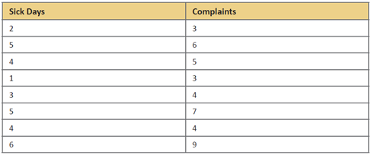
- Is the correlation between number of sick days and number of customer complaints statistically significant?
- What is the best prediction for the number of complaints that will be registered for an installer who takes five sick days during the period?
Use Excel to help you answer the questions.

Multiple Regressions Analysis
Develop a multiple linear regression equation that describes the relationship between tenure and the other variables in the chart above. Use the Analysis Toolpak located in Excel to perform this multiple regression.
Do these two variables explain a reasonable amount of the variation in the dependent variable?
Estimate the tenure of someone that could have $5.8($k) and 15 years of job satisfaction. Make sure to state your multiple regression equation in your example. What are some of things that you can estimate from the model? How effective is evaluating the R-squared of the model? What is the relationship between the independent and dependent variables?
Use Excel to help you answer the questions

Confidence Intervals
A hardware retailer has average sales of $64,235 with a standard deviation of $5,918 for a 12-month period. The mean monthly sales for all retailers in the chain are $59,844. Is this hardware retailer’s sales significantly different from all retailers in the chain at p= .05? Are they significantly different at p= .01? Calculate a .95 confidence interval for the data in problem.
Explain your findings and determine what question the confidence interval answers.

Correlation and Confidence Intervals

A car dealer is using the number of years customers have owned their vehicles to predict how long it will be before they elect to replace them. The correlation between the two is rxy = -.723 (the longer they have owned their present vehicles, the more quickly they are expected to replace them). The other relevant data are as follows for 32 customers:
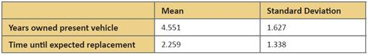
Based on the information above, answer the following questions:
- How long is the time to expected replacement for a customer who has owned a vehicle 6.5 years?
- Calculate .95 and .99 confidence intervals and explain your results.
- How will a larger standard deviation in the criterion variable affect the width of the confidence intervals? Why?
- Guided Response: Review several of your classmates’ postings. Respond to at least two classmates by commenting on whether or not you think there is a larger difference for the standard deviation. Explain how this data might impact business decision-making.

