Week 2 WebliographyAssignment:

- Locate an article, blog, or website on the Internet that pertains to a legal issue in selection.
- Post the link to the item in the Webliography area of our course with a briefdescription/summary in the Webliography area. You can find the Webliography by clicking on the word “Webliography” at the top of your course page.

- To submit to the Webliography, click “add new Entry”, and then fill in the form that pops up. Make sure to fill in all parts. If there is no site author, you need to find a different link (as that means the source is not a high quality source).

- Your summary in the discussion area should be brief (usually just a few sentences will suffice) and should represent your synopsis of the piece in your own words. Don’t copy from the article or website.
- Make sure that your link works. (Subscription only websites should not be used).
- Find a recent article or website (i.e. no more than 5 years old).
- Find a website article or item that has an AUTHOR.
- Make sure that your article is related to legal issues in selection (i.e. interviewing, pre-employment testing, background checks, job analysis, recruiting, etc.)
- Try not to replicate another student’s submission. Note these appear in the order that they are provided – so the professor can see who was “first.”
- See the screen shots below for how to enter the Webliography items.
- Some ideas for great items would be:
  - A link to a court case deciding a selection case of some kind (i.e. discrimination in selection)
  - A link to an EEOC decision or complaint news story about an action against a company for a selection decision
  - A link to a new law about selection
  - A link to an HR site discussing how to legally select applicants
  - A link about diversity in employment (recent and about selection)
  - A link about doing background checks (i.e. the state Departments of Labor have great information about this).

This assignment is worth 50 points.

Screen shots:
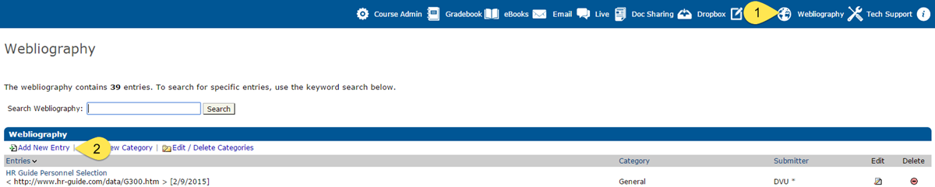
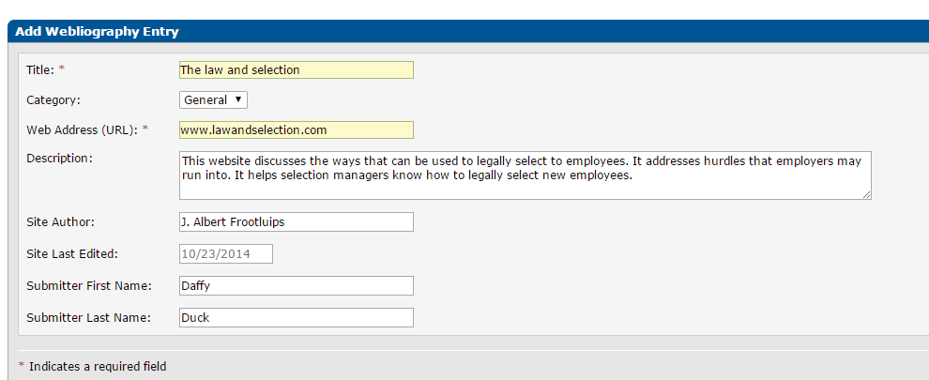

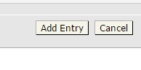

Click Add Entry when ready to submit.

