NETW240 Week 3 Lab: Managing User and Group Accounts
Task 1: Backup User and Group Files
See Chapter 5, User and Group Management
- Log on as vlab using the password: password.

- You are the new system administrator (superuser) responsible for the company’s internal Linux system. You are preparing to add all company employees to the internal Linux system that you administer. You begin by creating a user account for each employee. A user account consists of a username and an associated password. Your policy for the username will consist of the employee’s last name followed by their first initial. You will assign a password for each employee. Employees are instructed to change their password upon login. An acceptable password will consist of at least 8 characters consisting of letters (upper and lower case), numbers and symbols.
- Using the mouse, click on the Fedora icon. Select ‘System Tools’ and then select ‘Terminal’. A virtual terminal emulation window will appear. The window will provide access to the shell command-line prompt.
- Using the “switch user” (su) command, switch from standard user mode to the superuser mode. The password for root is password.

- As the superuser, you now have system-wide privileges.
- As a precaution, make a backup copy of the system’s /etc/passwd file. Using the copy command (cp), copy the /etc/passwd file to a file named /etc/passwd.old:
cp /etc/passwd /etc/passwd.old
- Copy the /etc/group file to a backup file named group.old:
cp /etc/group /etc/group.old
- Copy the /etc/shadow file to a backup file named shadow.old:
cp /etc/shadow /etc/shadow.old

Task 2 : The Telecommunications Department:
- Change directory location from /home which is your current working directory (the directory that the shell places you in at login) to /etc using the cd command. Use the pwd to verify that you are actually in /etc.
- Use the nano (or vi) text editor to open the passwd file for editing. The passwd file is the first file we edit when adding a new user account. The parameters making up each user’s account are stored here in plain text format. This file should already be populated with system data and the user account created when you loaded Linux. If the file is empty, check to make sure that you are in the /etc directory:

nano passwd

- The /etc/passwd file contains an entry for each user on the Linux system. Each user entry contains 7 fields of account information. Each field must be separated by a colon (:).

Fields making up /etc/passwd:
User Name: Password : User ID : Group ID : User Info : User Home Directory : Assigned Shell

- Using the down arrow, position your cursor on the blank line beneath the last user entry as shown below:
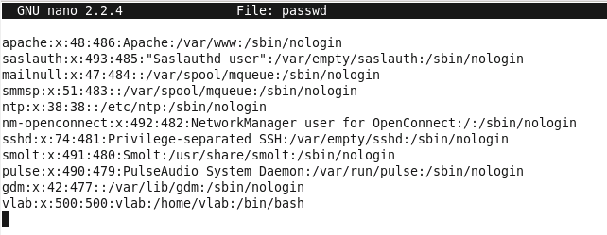
- Begin entering the account information for Don Roger as shown below. Be careful to place a colon (:) separator after each field (of the 7 fields) making up an /etc/passwd user account entry. Note: The !! in the password field allows a user to set a password upon first login.

rogerd:!!:505:505: Roger, D. Mgr IT (404) 292 7901 :/home/rogerd:/bin/bash

Note: A missing colon will prevent the user from properly logging-in.

- Enter the account information for Betty Bask as shown below:

baskb:!!:506:506: Bask, B. Mgr IT (404) 292 7902 :/home/baskb:/bin/bash

UNIX reserves the first set of User ID and Group ID numbers for system services that are included in the /etc/passwd file. For this reason, Linux defaults to the following beginning numbers for IDs.

User IDs start at 500 (Reserved system User IDs are 0 to 199). Primary Group IDs start at 500 (Reserved Group IDs are 0 to 101).

Note: Keep the user ID and primary group ID number the same for consistency; and, assign the next available user and group ID to prevent assigning the same ID to two different users.

- After adding Roger and Bask to /etc/passwd, save the /etc/passwd file and exit your text editor.

- Open the /etc/shadow file in nano (or vi). The shadow file is the second file we edit when adding a new user account. The actual encryted password is stored in this secure file beacuse /etc/passwd is readable by all system users. For security considerations, only root (the superuser) can read and change the /etc/shadow file.
The /etc/shadow file contains an encrypted password for each user on the UNIX system. Each user entry contains 9 fields of password information. Each field must be separated by a colon (:). The fields following the user name and encrypted-password are the “password aging” fields. These password fields have parameters that can be used to customize password options, such as preventing a user from changing their password back to their “old password” after changing it, usually every 3-6 months
Fields making up /etc/shadow:
User login name : Encrypted password : Days since password last changed : Days before password change permitted again : Days before password change required : Days warning before password expiration : Days before account deactivated : Date when account expires : Reserved for future use

- Using the down arrow, position your cursor on the blank line beneath the last user entry as shown below:
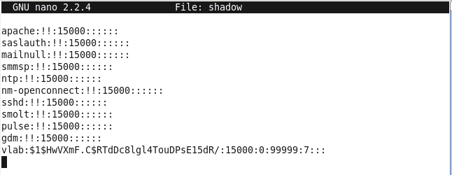
- Begin entering the password information for Don Roger as shown below. Be careful to place a colon (:) separator after each field (of the 9 fields) making up an /etc/shadow entry. Note: As in the /etc/passwd file, the !! in the encrypted-password field allows a user to set a password upon first login.
- Enter the shadow file information for Roger and Bask as shown below:
rogerd:!!:11:0:99999:7:::
baskb:!!:11:0:99999:7:::
- After adding Roger and Bask to /etc/shadow, save the /etc/shadow file and exit your text editor.
- Change directory to /home (using the cd command) and create home directories for Don Roger (rogerd) and Betty Bask (baskb):
cd /home
mkdir rogerd baskb
- Since you created Roger and Bask’s home directory as the superuser (root), root (the superuser) now owns these directories (the creator of a file will become the file’s owner). This will prevent Roger and Bask from having control of their own home directory. To remedy this problem, use the change owner (chown) command to change directory ownership from root to Roger and to Bask.
chown rogerd rogerd
chown baskb baskb
- Use the nano (or vi) text editor to open the /etc/group file for editing. The /etc/group file is the third file we edit when adding a new user account. The group file stores each user’s primary group ID and any number of secondary group IDs.
- The /etc/group file must contain the user’s “primary” group ID consisting of 4 fields of information. Each field must be separated by a colon (:). The user can then be assigned to any number of secondary group IDs as required, such as a project team’s group ID or to their department’s group ID, etc..
Fields making up /etc/group:
User login name : Group password (not required, show as ’’x’’) : Group ID : Group Members
- Enter the primary group information for Roger and Bask as shown below:
rogerd:x:505:
baskb:x:506
- Enter the secondary group information for Roger and Bask as shown below:
tcom:x:900:rogerd,baskb
Note: There is no limit to the number of secondary groups to which a user can belong. Each secondary group should be assigned to a number range that will not to interfere with primary group numbers. In this example, 900 is the group number for the telecommunication department’s group ID. Groups are added as needed and users assigned by adding their username in the last field separated by a comma (do not place any space between names and commas) otherwise when a user leaves the group, their name is deleted from the secondary group.
- After adding Roger and Bask to /etc/group, save the /etc/group file and exit your text editor.
- Using the change directory command “cd /home” change your current working directory from /etc back to /home.
- Since we created Roger and Bask’s home directory as the superuser (root), root (the superuser) is now the primary group owner over these directories (the creator of a directory will become the group owner). This will prevent Roger and Bask from taking primary group ownership over their own home directory. To remedy this problem, use the change group (chgrp) command to change group ownership from root to roger and to bask.
chgrp rogerd rogerd
chgrp baskb baskb

- Several files must be copied from the /etc/skel directory to Roger’s and Bask’s home directory. Three of these files are shown below. Files in /etc/skel can be customized by each user to enhance their home directory environment. In most cases, the superuser will edit the files for all users as a consistency measure. For example, the “date” command may be added to the .bash_profile file in order to display the date and time to a user upon log-on in text mode. All files in /etc/skel are hidden files and can be identified by the fact that their file name begins with a dot or period. The normal “ls” command will not display these hidden files – hence the skel or skeleton directory.
.bashrc .bash_profile .bash_logout
- Using the copy command “cp,” copy the /etc/skel files over to Roger and Bask’s home directory:
cp /etc/skel/.* /home/rogerd
cp /etc/skel/.* /home/baskb
- Using the change directory command, cd to /home/rogerd and enter the following command:
ls -l (the hidden files are not listed)
- Enter the “ls” command again with the “a” option to show all files both visable and hidden. Ensure that the . (dot) or hidden files were copied from skel.
ls -la (the dot files are listed – unhidden)
- Using the change directory command, cd to the top of the UNIX file system, called root and shown on the shell command-line as a forward slash (/):
cd /
- Verify that all user account entries made in the /etc configuration files are correct by using the “cat” command. If any fields are missing or incorrect, the user will not be able to properly log in to the system:
cat /etc/passwd
cat /etc/shadow
cat /etc/group
- Using the passwd command, set Roger and Bask’s user account password to “fedora.” The “passwd” command will prompt you for two passwords. An initial password, and a confirmation password, to ensure that you entered the password correctly. Passwords are case sensitive and not viewable as entered from the keyboard as a security measure.
# passwd rogerd
# passwd baskb
After setting the password to “fedora,” view each file again using the “cat” command. Pay close attention to the change made in the password field of the passwd and shadow files.
Note: This section allowed us to become familiar with “user account” entries, commands, and directory names and functions. The next section will allow us to use a single command to add a user account.
Task 3 : The Networking Department:
- Using the change directory command, change from your current working directory to root (/).
- Using the shell command-line, enter the useradd command along with user account information for Tom Ring and Ellen Net in The Linux Group’s Networking department.

useradd ringt –c “Ring, T Mgr Networking (404) 292 7903”

useradd nete –c “Net, E Mgr Networking (404) 292 7904”

- The “useradd” command adds the “user account” specified as the first argument on the command-line. All require account entries are posted to the appropriate files in /etc. The home directory is created and ownership transferred from root to the new directory owner. All /etc/skel files are copied into the home directory. The “c” option, above, places the appropriate general account information in the 5th field of the /etc/passwd file.

- Using the passwd command, set Net and Ring’s user account password to “fedora.”

# passwd nete

# passwd ringt

- Perform an ls –la command on /home. Determine if the two directories – ringt and nete – exist.

# ls -la /home

- Using the “cat” command, view the /etc/passwd; /etc/shadow; and /etc/group files to verify that the necessary entries were automatically created by the useradd command.

- Using the “groupadd” command, add the “netw” departmental group to the /etc/group file:

# groupadd netw -g 901

- Note: Our last group, telcom, was assigned a group ID of 900. Therefore, the next available group ID number in the 900 series range is 901. The –g option forces groupadd to assign a group ID of 901.

- Using the nano (or vi) text editor, add Net and Ring to the /etc/group file. Remember, do not place any spaces between user names in the netw group. Exit the text editor after you make these two entries.
netw:x:901,ringt,nete

- Assign a password to your the new user accounts by using the passwd command. Assign “fedora” as the password for ringt and nete.

- After exiting vi, execute the ls -la command on /home. Verify that tring and enet have the correct owner and group ownerships.

- # ls -l /home

- Using the “cat” command, view the contents of the /etc/group file to verify the accuracy of your last group addition.
Note: This section allowed us to become familiar with the “useradd” command as a convenient way to add new user accounts. The next section will allow us to use the gnome’s Graphical User Interface to add new user accounts.
Task 4 : The Applications Department
- Using the “exit” command, exit from the shell’s virtual terminal window. This should place you back in the GNOME graphical desktop.# exit

- To add user accounts for employees in The Linux Group’s Applications department, you will take advantage of a graphical user interface window supplied by GNOME.

- To access the GUI click on ‘System’ --> 'Administration' --> ‘Users and Groups'. The GUI window will appear together with the names of all users added to your system since it was loaded.

- Examine the “Users and Groups” window. Notice the “Add User” and “Add Group” icons on the window tool bar. Click on the ‘Add User’ icon. A “Create New User” window appears. Add the following user account information in this window and then click the ‘OK’ button. Add the next user account and click the ‘OK’ button.

- User Name: based Full name: Base, D Mgr Applications (404) 292 7905 Password: fedora Confirm Password: fedora Login Shell: /bin/bash Home Directory: Check the box and /home/based appears Create a private group for the owner: check the box Specify User ID: Leave this box blank to select next ID Click the “OK” button

- You will get a message saying that your password is weak. Click on OK to accept and continue.

- User Name: cordr Full name: Cord, R Mgr Applications (404) 292 7905 Password: fedora Confirm Password: fedora Login Shell: /bin/bash Home Directory: Check the box and /home/cordr appears Create a private group for the owner: check the box Specify User ID: Leave this box blank to select next ID Click the “OK” button

- You will get a message saying that your password is weak. Click on OK to accept and continue.

- Click on the “Add Group” icon and a “Create New Group” window appears. Enter the following new group account information. Click on “OK” when finished:

- Enter Group Name: apps Specify Group ID Manually: check the box and enter 902. Click “OK”

- Click on the ‘Groups’ tab immediately above the list if users. This will bring up a list of all groups. Select the ‘apps’ group. Select ‘Properties’ on the top tool bar. Select the ‘Group Users’ tab. Use the slide bar to place a check mark in the “box” by cordr and based names. Click the ‘OK’ button.

- Close the “Users and Groups” window.

- Bring up a virtual terminal window and the UNIX login. Use the following command to login as rogerd:

su - rogerd

- Use the following command to verify that you have logged in as rogerd:

who
pwd

- Log in as baskb by using the following command:

su - baskb

- You will need to provide the password that you typed in when you created the 'baskb' user account.

- Repeat this login technique and logging in as nete, ringt, and based to verify their user accounts have been created.
Lab Report Preparation
Before you log off, open a Terminal window. Maximize the Terminal window and change directory to /etc. Perform the follow steps for your Lab Report requirements.
- Execute the cat passwd command. Make sure that the new user accounts are shown in the terminal window. Capture the Linux desktop and save it this image to your Lab Report document in the space allocated for the /etc/passwd file.
- Execute the cat shadow command. Make sure that the new user accounts are shown in the terminal window. Capture the Linux desktop and save it this image to your Lab Report document in the space allocated for the /etc/shadow file.
- Execute the cat group command. Make sure that the new user accounts are shown in the terminal window. Capture the Linux desktop and save it this image to your Lab Report document in the space allocated for the /etc/group file.
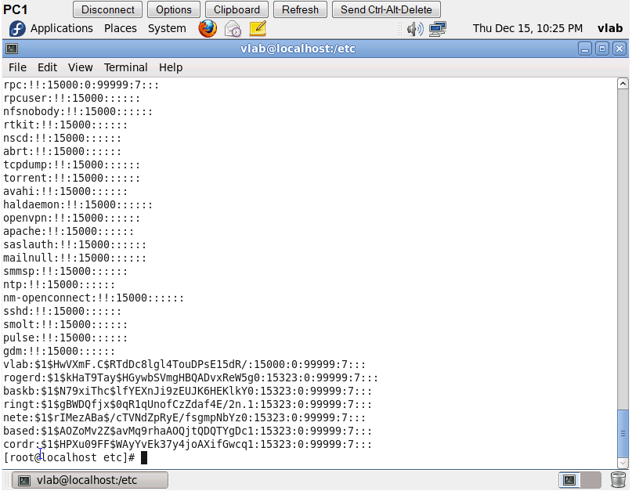
- Also be prepare to discuss the three techniques used in this lab to manage new user and group accounts.

