Report Title:

Factory Waste in Terms of Thermal Pollution
Causes, Effects and Best Solutions

Prepared For
Mr. John Hamilton
GUYS, PLEASE NOTE: THIS IS AN EXAMPLE WITH REASONABLE FORMATING, HOWEVER, IT ALSO CONTAINS ERRORS….
By
XXXXXXXXXXXXXXXXXXXXXXX
ID: XXXXXXXXXXXXXX
English 214
Section: XX
Serial Number: XX

Table of Content

INTRODUCTION …………………………………………….……………………………………………………….……… 1
- BACKGROUND. ……………..………………………………………………………………………….………… 1

- CAUSES OF THERMAL POLLUTION DUE TO FACTORY WASTE: …………………………….. 2

- Introduction. …………………………………………………………….……………………………………….. 2
- Industrial Use of Water as a Coolant. …………………………………………………………….…… 2
- The Burning of Fossil Fuels. …………………………………………………………………….…………. 3
- Urban Runoff. ……………………………………………………………………………………………………. 4
- Summary. ……………………………………………………………………………………………………..…… 5

- EFFECTS OF THERMAL POLLUTION DUE TO FACTORY WASTE: …………………………... 5
- Introduction. ……………………………………………………………………………….…………………..… 5
- Warm Water. ………………………………………………………………………………………..……….….. 5
- Redistribution of Organisms in the Local Community. …………………………………...….. 6
- Economic and Environmental Damage. …………………………………………………….………… 7
- Summary. …………………………………………………………………………………………………………... 7

- THE BEST SOLUTIONS FOR THERMAL POLLUTION DUE TO FACTORY WASTE: ……... 7
- Introduction. …………………………………………………………………………………………………….... 7
- Cooling Towers (short term). …………………………………………………………………………….… 8
- Regenerative Thermal Oxidation (intermediate term). ……………………………………….. 9
- Green Cities (long term). ………………………………………………………………………………..…. 10
- Summary. ………………………………………………………………………………………………....….….. 11

- LIMITATION. ……………………………………..……………………………………………….….…………. 11

- FUTURE RESEARCH. …..……………………………………………………………………….……………. 11
CONCLUSION ………………………………………………………………………………………………….………..... 12
WORK CITED ………………………………………………………………………………………….………... 13
-ii-

INTRODUCTION:
The world is full of environmental issues that made scientists and even people very confused and frightened. For example, pollution, global warming and ozone layer all of these examples have Devastating consequences on our planet. Pollution is one of the most serious problems in this age and has dangerous effects on humans, animals, plants and more importantly earth. Moreover, it includes all components of earth, such as land, water, air and thermal pollution. Thermal Pollution is a main type of pollution, which has its own causes and effects on the environment, mostly comes from certain industrial behaviors. Factory waste, due to the way of discharge, can be counted as the major source of thermal pollution. This report discusses thermal pollution due to factory waste in three main sections. First section, introduces the problem and gives some background and history about thermal pollution due to factory waste. Second section, explains the major causes of thermal pollution due to factory waste. Third section, shows the major effects of thermal pollution due to factory waste. Last section, provides the best solutions for thermal pollution due to factory waste.

I. BACKGROUND:
Pollution started back in 18th century during the industrial revolution, but the question is what is pollution and thermal pollution [1]? The general concept of pollution is the introduction of contaminants into a natural environment that causes instability, disorder, harm or discomfort to the ecosystem i.e. physical systems or living organisms [2]. In the other hand, the broadest definition of thermal pollution is the degradation of water quality by any process that changes water temperature [3]. Another definition refers to an increase of temperature in

-1-
a body of water due to human or environmental causes [4]. This kind of pollution leads to multiple of serious environmental disasters i.e. global warming [2]. It has been estimated that thermal pollution is responsible for almost 50 percent of the pollution present in the United States [5]. The Blacksmith Institute issues annually a list of the world's worst polluted places [2]. In 2007 issues the top nominees are located in China and India, mostly because of factory waste [2]. Furthermore, 80 % of warm water comes from factory this proves that factory waste indeed is source number one for thermal pollution [6].

II. MAJOR CAUSES OF THERMAL POLLUTION DUE TO FACTORY WASTE:
Introduction:
Firstly, there are several main causes of thermal pollution, each single one of them leads to serious environmental consequences. However, industrial use of water as a coolant, power plants creating electricity from fossil fuel and urban runoff are the major causes of thermal pollution due to factory waste.
K
- Industrial Use of Water as a Coolant:
One of the major causes of thermal pollution is industrial use of water as a coolant. Factories and power plants usually use the nearest source of water, which is often ocean, sea or lake, to keep factory machines and equipment cool and functional [7]. Despite how cheap and effective this way is, this way of cooling process can spoil the aquatic ecosystems [7, 8]. In other words, it can damage and harm all kind of life inside water like fish and algae [7, 8]. Water is typically siphoned away from a source, run through cooling systems at a factory or plant,

-2-

then returned to the original source [7, 8]. Unfortunately, in the process of cooling machines the water temperature rises by several degrees [3, 4]. This warm or hot water return back into a natural source can destroy food sources or kill kind of fish that life under a certain temperature [3, 4, 5]. Overall, many environmental scientists consider the industrial use of water as a coolant to be the first major cause of thermal pollution due to factory waste [4, 6, 8].

- Power Plants Creating Electricity From Fossil Fuel:
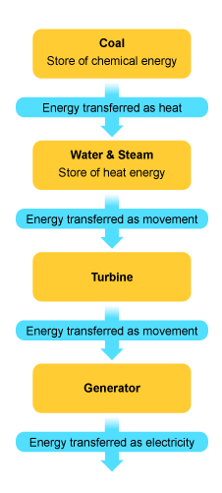
The second major cause is Power plants creating electricity from fossil fuel. However, this cause doesn't restrict to thermal pollution, but it also includes air pollution. Fossil fueled plants use oil, coal or gas in the generation of electricity, figure 1 explains the steps to generate electricity from fossil fuel in figure 2 [9,10].

Figure 2 [10]
Figure 1
(Energy transfer for the generation of electricity from a fossil fuel) [9]

-3-

50 % of electricity produces from fossil fuel, which is done by burning huge amount of fossil fuel for each time [11]. Overall, heat resulting from fossil fuel rises temperature that causes thermal pollution.

- Urban Runoff:
The last major cause of thermal pollution due to factory waste is urban runoff. Urban runoff is surface runoff of rainwater created by urbanization. This runoff is a major source of thermal pollution in many parts around world [12]. In addition, the urban runoff increases temperatures in streams, harming fish and other organisms [12]. Diagram 3 shows urbanization form factories and where it goes [13].
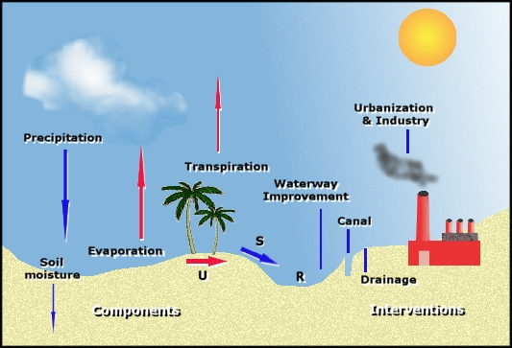
Figure 3 [13]

Beside temperature, urban runoff causes pH, which is a measure of the acidity or basicity of a solution, and dissolved oxygen [12]. Last but not least, urban runoff

-4-

due to the damages that can make, it counts as one of the major causes of thermal pollution due to factory waste.

Summary:
Finally, from the above we can conclude that industrial use of water as a coolant, power plants creating electricity from fossil fuel and urban runoff are the major causes of thermal pollution.

III. MAJOR EFFECTS OF THERMAL POLLUTION DUE TO FACTORY WASTE:
Introduction:
First of all, thermal pollution due to factory waste has serious and devastating effects. However, warm water, redistribution of organisms in the local community and environmental damages are the major effects of thermal pollution due to factory waste.

- Warm Water:
The first and the most dangerous effects of thermal pollution due to factory waste is warm water. One of the primary results of warm water is the low level of dissolved oxygen (DO) in the water [14]. Fish depend on a certain amount of oxygen to live underwater [4, 14]. However, the decrease in levels of dissolved oxygen in water can directly harm fish, algae etc [4, 14]. Furthermore, it kills Fish eggs causing a sharp decrease in the population [4, 14]. Rise temperature is
-5-
another serious consequence of warm water which leads to competition for fewer food resources that left. Figure 4 shows biological impacts of low dissolved oxygen in the water [15]. Last but least, warm water is the most dangerous effect thermal pollution due to factory waste.
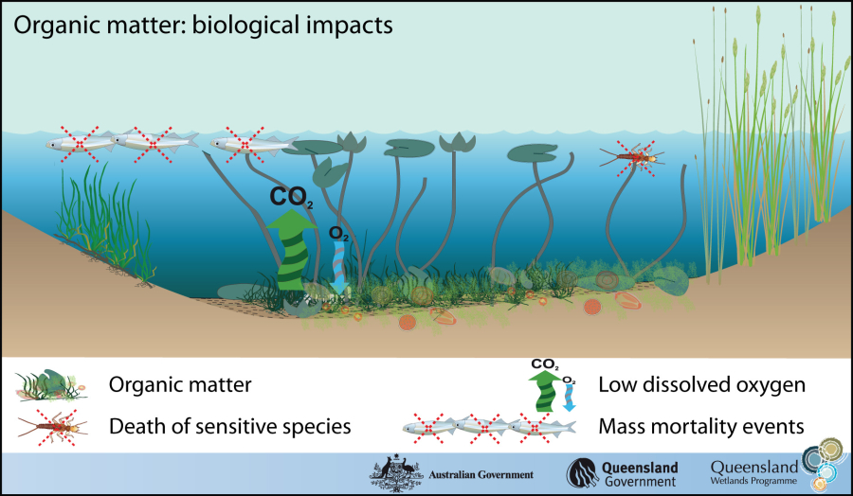
Figure 4 [15]

- Redistribution of Organisms in the Local Community:
The second major effect of thermal pollution due to factory waste is redistribution of organisms in the local community. The composition and Different of communities in the area of cooling water discharges from power plants can be harmfully affected by the direct death of organisms or movement of organisms away from unfavorable temperature or oxygen environments [4]. For example, the discharge of cold bottom water from deep water reservoirs behind large dams has changed the downstream biological communities [4]. Overall, redistribution of organisms in the local community is one of the major effects of thermal pollution due to factory waste.
-6-

- Environmental Damages:
The last major effect of thermal pollution due to factory waste is environmental damages. This effect could include the two effects at the top, but it goes beyond that to humans, animals and the entire earth. Moreover, the primary effect of thermal pollution are direct thermal shock on the whole area that infected by factory waste [4]. Lastly, environmental damages are one of the major effects of thermal pollution due to factory.
Summary:
Finally, thermal pollution due to factory waste has several serious effects on the environment. However, warm water, redistribution of organisms in the local community and environmental damages are the major effects of thermal pollution due to factory waste.

IV. THE BEST SOLUTIONS FOR THERMAL POLLUTION DUE TO FACTORY WASTE:
Introduction:
Firstly, to solve the problem of thermal pollution due to factory waste we need to admit that there is a problem. Secondly, we have to look for solutions to this problem. However, the best solutions for thermal pollution due to factory waste can be divided to three sections short term, intermediate term and long term solution. Cooling towers is direct and short term solution. Regenerative thermal oxidation is also direct, but it is intermediate term solution. Green cities are indirect and long term solution.
-7-
- Cooling Towers:
The first best solution for thermal pollution due to factory waste is cooling towers. This short term solution provides one way in which factory can follow permit restrictions. "Cooling towers are the surest way to solve thermal pollution problems, because the cooling results can be predicted with a high degree of accuracy prior to installing the towers," said Robert C. Brink, president and CEO of Tower Tech, Inc. in Oklahoma City [16]. Ever since it became an urgent need for cooling towers, some factories rent cooling towers to cool water before discharging [16, 17]. "These facilities pump all or part effluent through the cooling tower and then back to the discharge to diminish the ultimate temperature before it reaches the surface water," said Kent Zammit, manager for cooling water technologies at Electric Power Research Institute (EPRI) in PaIo Alto, CA [16]. Figure 5 shows a substantial thermal pollution project at the utility Cinergy Corporation [16].
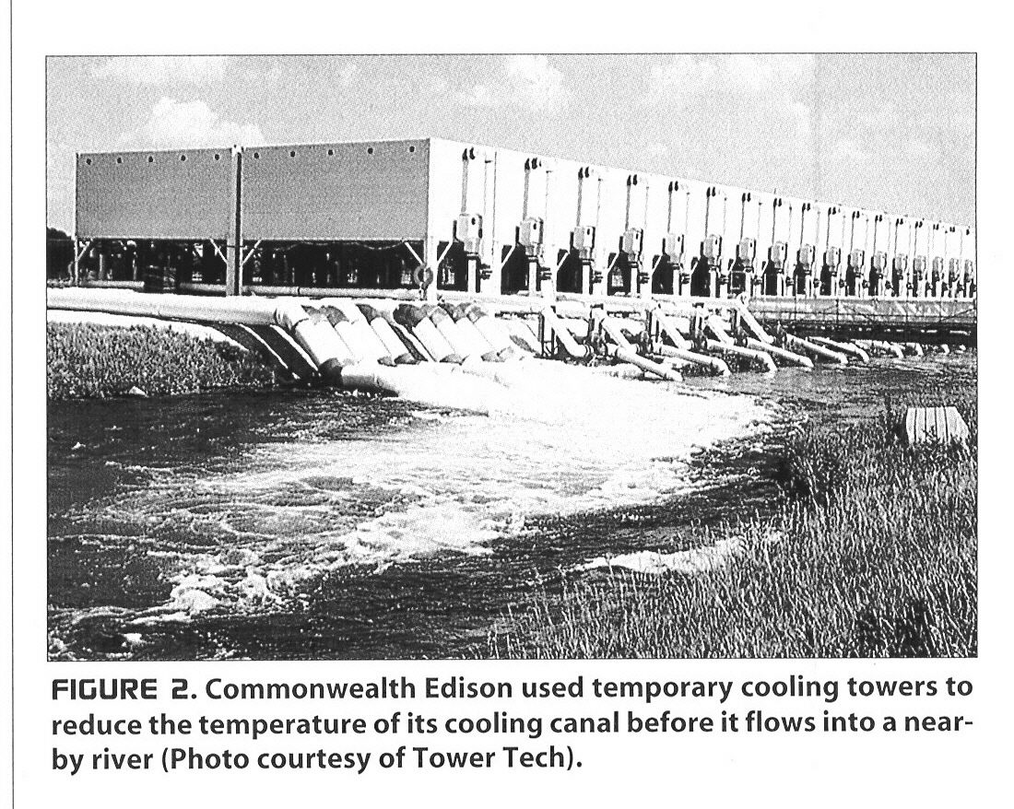
Figure 5 [16]

Overall, most experts agree that cooling towers are the quickest, most effective solution to thermal discharge issues.
-8-

- Regenerative Thermal Oxidation (RTO):
The second best solution for thermal pollution due to factory waste is regenerative thermal oxidation (RTO). This intermediate term solution and other types of thermal oxidation systems have proven to be a highly effective and energy-efficient method of abating volatile organic compounds (VOCs) and other pollutants emitted by industrial plants [17]. Thermal oxidizers are essentially incinerators that thermally or catalytically convert pollutant-laden emissions into carbon dioxide and water vapor [17, 18]. The oxidation process typically achieves better than 99 % destruction removal efficiency (DRE) levels for VOCs, hazardous air pollutants (HAPS) and odors [18]. Figure 6 shows the steps of regenerative thermal oxidation [18]. Last but not least, regenerative thermal oxidation (RTO) counts to be one of the best solutions for thermal pollution due to factory waste.
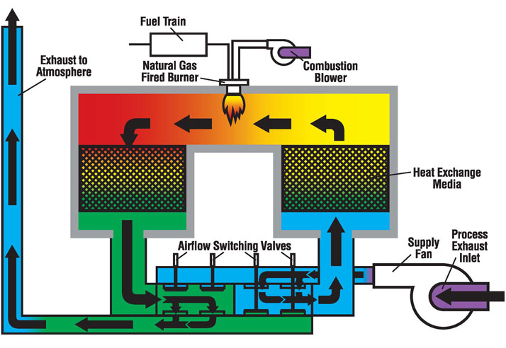
Figure 6 [18]

-9-
- Green Cities:
The last best solution for thermal pollution due to factory waste is green cities. This solution is a long term and indirect solution, but very effective for all kind of pollution. Green city is dedicated to increase the compatibility of cities with their local natural systems by providing resources to link individuals and group with each other and community-based ecological activities [19, 20]. Today, many city mayors are working to get their cities focused on the environmental movement [20]. By successful to achieve green city status, leaders are acting to improve the quality of the air, lower the use of non-renewable resources, encourage the building of green homes, offices, and other structures, reserve more green space, support environmentally-friendly methods of transportation, and offer recycling programs[20]. Abu Dhabi, capital of the United Arab Emirates (UAE), the world's third-largest oil exporter, is building a $22 billion carbon-neutral city near its international airport [21, 22]. Masdar's Abu Dhabi Future Energy signed an agreement on May 30 to buy three solar-panel manufacturing facilities from Santa Clara, CA-based Applied Materials for $2 billion. Meanwhile, in Dubai, the UAE's other futuristic city, the Dubai International Financial Center (DIFC) announced new regulations to address the needs of family-run institutions and to encourage ultra-wealthy families to establish holding companies at the DIFC to manage their wealth [22]. We can learn from Abu Dhabi experience the passionate and readiness to spend billions on such a project. Furthermore, A green city will typically already use or have plans to use alternative fuels. These fuels can include biomass, hydroelectric, geothermal, solar, and wind [23]. Therefore, it is good for the environment, because it is use natural sources that does not cause pollution. Overall, green cities are one of the best indirect and long term solutions for thermal pollution due to factory waste.

-10-
Summary:
Finally, the best solutions for thermal pollution due to factory waste can be divided to three sections short term, intermediate term and long term solution. Cooling towers is direct and short term solution. Regenerative thermal oxidation is also direct, but it is intermediate term solution. Green cities are indirect and long term solution.
V. LIMITATIONS:
First of all, thermal pollution is wide and complex subject, but I focused in Particular title, so I didn't find any difficulties researching for it. However, I faced some difficulties finding anything about thermal pollution due to factory waste related to Saudi Arabia. Finally, this report in general is applicable everywhere and every time.

VI. FUTURE RESEARCH:
First of all, I really hope my report contributes to solve thermal pollution due to factory waste. Secondly, as an electrical engineer I intend to find new solutions or alternative sources for the factories to use other than water. These alternative sources can contribute to reduce thermal pollution due to factory waste. Finally, I recommend everyone to participate to find solutions thermal pollution due to factory waste.

-11-

CONCLUSION:
Finally, Pollution is one of the most serious problems at this time. Thermal pollution is one of the main types of pollution and has very devastating effects on the environment. Most of the causes of thermal pollution related to certain industrial behaviors. This discussed thermal pollution due to factory waste and explained the major causes and effects and provided the best solutions. First section, introduced the problem and gave background about it. Second section, explained the major causes of thermal pollution due to factory waste, which are industrial use of water as a coolant, power plants creating electricity from fossil fuel and urban runoff, in detail. Third section, showed that warm water, redistribution of organisms in the local community and environmental damages are the major effects of thermal pollution due to factory waste. Last section, presented cooling towers regenerative thermal oxidation and green cities as the best solutions for thermal pollution due to factory waste.

-12-

WORK CITED

- "Environmental History Resources".

http://www.eh-resources.org/timeline/timeline_industrial.html.

"Pollution". http://en.wikipedia.org/wiki/Pollution.

"Thermal Pollution."

http://www.pollutionissues.com/Te-Un/Thermal-Pollution.html.
- Ellis, Jessica. "What Is Thermal Pollution?".
http://www.wisegeek.com/what-is-thermal-pollution.htm.
- "The Effect of Industrial Pollution". http://www.ehow.com/about_5155119_effect-industrial-pollution.html

"Thermal Pollution". http://www.join2green.com/ThermalPollution.aspx.
- Turpin, Joanna R. "A Solution for Thermal Pollution". Engineered Systems 1 Sep. 2004: ProQuest Science Journals, ProQuest. Web. 24 Dec. 2010.
- "Effects of a thermal pollution". http://www.polmar.com/pollution/thermique_e.htm.
- "Fossil Fuels". http://www.bbc.co.uk/schools/gcsebitesize/science/aqa/energy/mainselectricityrev1.shtml
- "Making Electricity".
http://progress-energy.com/aboutenergy/learningctr/electricity/making.asp.
- "Heat and Thermal Pollution". http://focusfusion.org/index.php/site/article/heat .
- "Urban runoff". http://en.wikipedia.org/wiki/Urban_runoff
- "The Urban and Industrial Environment". http://www.globalchange.umich.edu/globalchange2/current/lectures/urban2/urban_indust.html.

Zeeshan, Amin. "Causes and Impacts of Thermal Pollution". http://www.suite101.com/content/causes-and-impacts-of-thermal-pollution-a291023 Sep. 28, 2010.

-13-
- "Biological impacts". http://www.epa.qld.gov.au/wetlandinfo/site/SupportTools/MonitoringExtentAndCondition/Stressormodeloverview/Nutrients/Condition.html.
- Joanna R Turpin. "A Solution For THERMAL POLLUTION". Engineered Systems 1 Sep. 2004: ProQuest Science Journals, ProQuest. Web. 17 Jan. 2011.
- vSims, P. "POLLUTION CONTROL". ISHN 42.1 (2008): 52-53. ABI/INFORM Trade & Industry, ProQuest. Web. 24 Dec. 2010.
- "Regenerative Thermal Oxidation". http://www.pollutiononline.com/product.mvc/Regenerative-Thermal-Oxidation-0001.
- "What is a Green City?". http://www.wisegeek.com/what-is-a-green-city.htm.
- "Green City Project". http://www.sustainable-city.org/orgs/gcp.htm.
- Platt, G.. ""GREEN" CITY RISING NEAR ABU DHABI. " Global Finance 1 Jul 2008: ABI/INFORM Global, ProQuest. Web. 17 Jan. 2011.
- "Masdar Scales Back Role in Abu Dhabi's Green City. " Oil Daily 19 Mar. 2010: ABI/INFORM Trade & Industry, ProQuest. Web. 17 Jan. 2011
- "Guess Who's Building a Green City". http://www.businessweek.com/magazine/content/07_52/b4064057939494_page_2.htm.

-14-

