This is a client server monitoring system project design. I need help to upgrade this program.
The client side, just upgrade 2A to be like 2B, username will be display, password , the people the once are chatting with and others. Just like in 2B.
2A

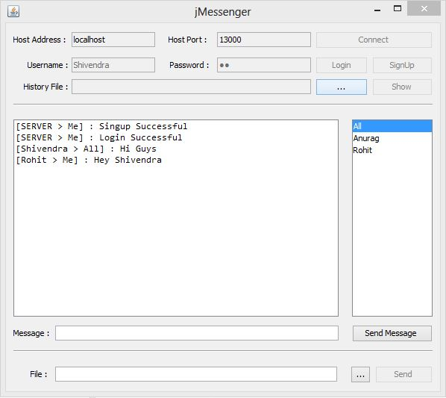
2B

