What’s In Trend Box Business Plan
Caio Corona, Chelby Guzman, Josie Schmid, Kelsey Lawrence, Ray Makore,
Tina Watson, & Yuting Lei
This paper is submitted in partial fulfillment of the requirements for BUS 5893
Texas Woman’s University
School of Management
Dr. Louis F. Carfagno, D.M
April 1, 2016

This business plan and associated material were prepared as an academic exercise ONLY in a Texas Woman’s University (TWU) School of Management class. This material is to ONLY be used for academic purposes. No one has permission to use it for any other purpose. No one should rely on or take any action based upon this material; presentations, information, forecasts, or conclusions reached in this plan and associated material. Anyone taking any action based upon anything in this plan or associated material does so without TWU's authorization and at their own sole peril. TWU assumes NO risk or liability, and provides NO warranty or indemnity of any sort based on the material in this business plan or associated material to anyone.

Abstract
The paper identifies an opportunity XXX

Table of Contents
1.0 Non-disclosure Agreement
2.0 Executive Summary
2.1 Mission Statement
2.2 Vision Statement
2.3 Company Enterprise
2.4 The Offerings
2.5.1 Potential Market
2.5.2 Addressable Market
2.5.3 Capturable Market
2.6 Results of Prospective Operations
2.7 Product Service Value Analysis
Must have an academic definition
Must have an academic definition
2.9 Risk Factors
Must have an academic definition
2.10 Sources and Uses of Funds
2.11 Enterprise Value
Must have an academic definition
2.12 Summary of Executive Management’s Background
2.13 Conclusion
3.0 The Enterprise - TING
3.1 XX Model
3.2 Objectives
3.3 History
3.4 Organization
3.4.1 Personnel
3.4.2 Personnel Count
3.5 Operations
3.6 Future
4.0 The Market
4.1 Description
4.3 Segmentation Must have an academic definition
4.4 Market Size Must have an academic definition
4.4.3 Micro Demand Curve Must have an academic definition
4.5 Environmental Models and Analysis
4.6 Alternative Solutions and Disruptive Technologies (if it applies)
5.0 Offerings - TING
5.1 Description (Products/Services)
5.2 Cost to Produce
5.2.3 Engineering Hours
5.2.4 Engineering Hours
5.2.5 Setup Time
5.2.7 Manufacturing Hours
5.2.8 Average Labor per XX
5.2.9 Material Cost
5.3 Competitive Advantages/Disadvantages
6.0 Marketing Strategy - Kelsey
6.1 Target Markets
6.2 Market Image Must have an academic definition
6.3 Promotion
6.3.1 Image
6.3.2 Publicity - free
6.3.3 Advertising - pay for 10,000 business cards the first year at $0.03 each which comes out to $320 for the first year from Vistaprint. Also for the first 6 months after launching our box we should put $20.00 a week toward Google adwords and Facebook banners to generate more leads and get our name out there. After the first 6 months of advertising are over we will evaluate and see if we need to advertise for another 6 months at $20 a week, it just depends on where we see the most leads are coming from. At $20 a week for 6 months that would be $480 for facebook banner or Google advertising.
6.4 Pricing Methodology
6.5 Sales and Sales Cycle
6.6 Channels of Distribution
6.7 Logistics
6.8 Time to Market Analysis
7.0 Competitive Analysis
7.1 Competitor Identification and Capabilities Analysis
7.2 Detailed Value Index Must have an academic definition
7.3 Competitor Strengths and Weaknesses and Positioning
8.0 Development Program
8.1 Objectives-
The main focus will be on short term goals. Learning and development will be an ongoing and active process. This is to prevent knowledge and skills from becoming obsolete within a few months. Quarterly improvement goals and strategies for business development will be discussed and implemented by partners through weekly staff meetings. Development programs are not set in stone. Change equals progress and opportunities to expand the business will be assessed as they come up.
8.2 Schedules-
Years 1-5:
Months 1-2: Recruit members and gather products.
8.3 Technology -
8.3.2 Resale of Inventory -
9.0 Operations / Production
9.1 Organization / Staffing Plan
9.1.1 President / CEO -
9.1.3 Production Staffing - Josie, Ray, Ting, Caio, Kelsey, Chelby, and Tina:
9.1.5 Marketing and Sales -
9.1.6 Accounting and Finance -
9.2 Suppliers
Packing materials are provided by FedEx in Years 1 and 2. Once profit margins are met, packaging will be designed for the upcoming quarter. Branded packaging supplier is to be determined and may be subject to change depending on availability, sales volume, and cost that year. FedEx supplies packaging as part of their volume shipping membership, which cuts costs, however limits brand awareness. Distributing branded packaging is the long term goal.
9.2.2 Material Providers -
9.4 Quality
9.4.1 Methodologies -
9.4.2 Certifications
9.5 Inventory
9.5.1 Work in Process
9.5.2 Raw Materials
9.6 Training
9.6.1 HR Required-
10.0 Investment Capital
10.1 Initial Funding - Sources
10.2 Use of Funds
10.5 Break-Even Analysis
11.0 Financial Projections
11.1 Year One Through Five Income/Expense
11.2 Year One Through Five Cash Flows
11.3 Year One Through Five Balance Sheets
12.0 Financial Alternatives
12.1 Expected Case
13.0 Financial Addenda
13.1 Assumptions
13.2 Ratios
13.2.1 Liquidity Ratio
13.2.2 Profitability Ratio
13.2.3 Leverage Ratio
14.0 Financial Charts
15.0 Risk Analysis
16.0 Resumes of Key Players
17.0 Appendices
Appendix A – Cost of Harness
Appendix B – Timeline
Appendix C – Income Statement
Appendix D – Cash Flow
Appendix E – Balance Sheet
Appendix F – Fully Burden Labor
Appendix G – Assets and Operating Expenses at Startup
References

List of Tables

List of Figures

1.0 Non-disclosure Agreement
The undersigned Recipient acknowledges that the information provided in this strategic plan is confidential.
The Owner of the information has disclosed certain confidential and proprietary information to Texas Woman’s University. The confidential information shall include all data, materials, products, technology, computer programs, specifications, manuals, business plans, software, marketing plans, financial information, and other information disclosed or submitted, orally in writing, or by any other media.
The Recipient agrees that the confidential information is to be considered confidential and proprietary to Owner and Recipient shall hold the same in confidence, shall not use the confidential Information other than for purposes of educational evaluation, and shall disclose it only to its faculty or other staff with a specific need to know. Recipient will not disclose, publish, or otherwise reveal any of the confidential Information received from the Owner to any other party whatsoever except with the specific prior written authorization of the Owner.
Upon request, this document is to be immediately returned to Texas Woman’s University.
Name Signature Date
XX ________________________________ _______________
XX ________________________________ _______________
XX ________________________________ _______________
XX ________________________________ _______________
XX ________________________________ _______________
This is a strategic business plan for educational purposes. It does not imply an offering of securities.

2.0 Executive Summary

2.1 Mission Statement
Healthy living choices made simple by providing people these items in What’s In Trend Box.

A wholesome taste of natural living conveniently delivered to your doorstep.

Established in Dallas, Texas, What’s In Trend Box partners with local favorites and provides nourishing food and home alternatives to help families nationwide achieve a healthier lifestyle. We provide a simple healthy living choice conveniently delivered to your doorstep.

2.2 Vision Statement
What’s In Trend Box is a healthy living choice made easy by monthly deliveries. It inspires a better lifestyle and influences a healthier routine by offering the latest health trends straight to your doorstep.

2.3 Company Enterprise
A partnership of individuals dedicated to bring non-GMO, organic, and/or local products to your home.

Hey guys,

My husband is a manager at Sprouts and said that the grocery business proclaims New Mexico, Louisiana, and Oklahoma in addition to Texas as local. I.e. anything that can be shipping within 1 business day is local. We could amend the statement back to local and proclaim these states as part of our region. - Josie

2.4 The Offerings
Receive a monthly box of all natural, non-GMO items, anything from delicious healthy snacks to green sustainable home goods. Conveniently switch to a healthier lifestyle and feel good knowing that every brand you discover in the box cares about people and the planet.

Business Problem being solved or addressed:
We realize that even though there are countless reasons to stay healthy, some may still find it challenging to step out of their comfort zone and switch to a healthier lifestyle. The goal of What’s In Trend Box is to help guide people toward living a healthier lifestyle.

2.5.1 Potential Market

Potential market represents the upper limits of market for a product or business. The potential market for a subscription box business model in the US, is already estimated to be around $3Billions.

2.5.2 Addressable Market

Addressable Market or Total Addressable Market (TAM) refers to the universe of revenue opportunities for a product or service. The subscription box business falls within the greater ecommerce retail sales which are represented in the chart below, which sales are estimated to be in the upper $300Billions in 2016.

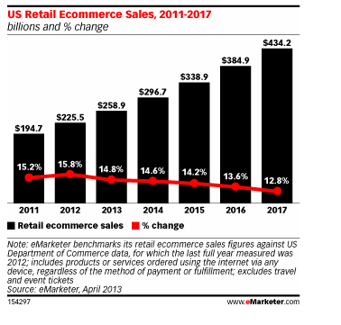

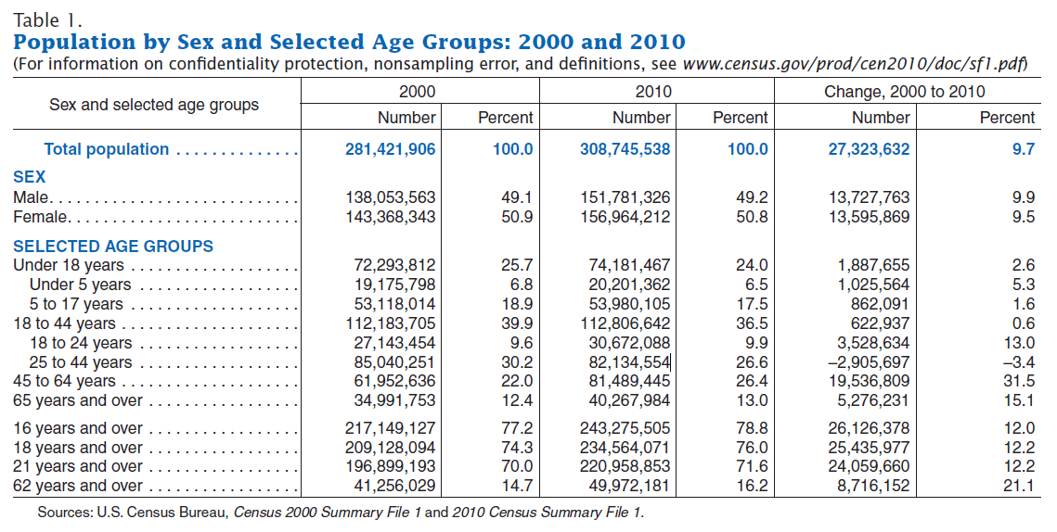

http://www.census.gov/prod/cen2010/briefs/c2010br-03.pdf
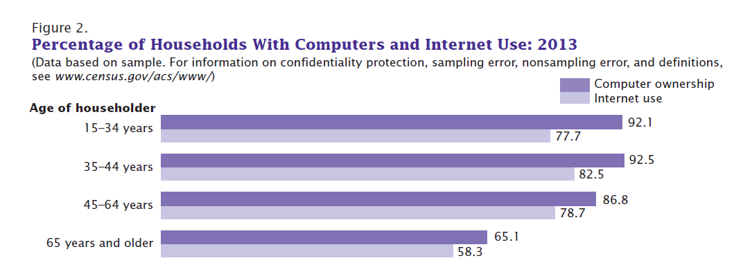

2.5.3 Capturable Market - CAIO

Must have an academic definition

2.6 Results of Prospective Operations
The results of prospective operations of What’s in Trend Box is to have 100,000 subscribers, by year 5

2.7 Product Service Value Analysis

Must have an academic definition
2.8 SWOT Analysis

A SWOT analysis is a tool that identifies the strengths, weaknesses, opportunities, and threats of an organization. This analysis determines what may facilitate in organization in accomplishing its objectives and what barriers must be overcome or minimized to achieve desired results. (http://www.investopedia.com/terms/s/swot.asp)

Strengths
Predictable revenue: customers billed on a recurring basis
Develop customer relationships
Good Publicity for vendors (http://articles.bplans.com/the-pros-and-cons-of-running-a-subscription-service/)

Weaknesses
High Competition
Adapt to new technology
Research and development
Opportunities
Acquisition synergies
(http://pestleanalysis.com/swot-analysis-for-a-delivery-service-company/)

Threats
Changing taste of consumers
Maintaining Value
Low Barriers to entry
Potential over-saturation in market
(http://articles.bplans.com/the-pros-and-cons-of-running-a-subscription-service/)
Security Breeches
Healthy Surprise, Blissmo BREAKbox, Jacked Pack, Bestowed, Love with Food, and Conscious Box
http://greatist.com/health/13-healthiest-subscription-boxes

http://healthland.time.com/2012/12/31/snack-boxes-the-latest-healthy-eating-trend/

Must have an academic definition

2.9 Risk Factors

Must have an academic definition

2.10 Sources and Uses of Funds

2.11 Enterprise Value

Must have an academic definition

2.12 Summary of Executive Management’s Background

2.13 Conclusion

3.0 The Enterprise - TING

3.1 Porter’s Model + 2

Threat of New Entry
- Not too expensive to enter the industry
- Little to no training
- No technology protection
- Low barriers to entry
- Some cost benefits

Competitive Rivalry
- A lot of competitors
- Low switching costs
- Low customer loyalty

Buyer Power
- Few, large supermarkets
- High price sensitivity
- Ability to substitute

Supplier Power
- Moderate number of suppliers
- Niche market
- Able to substitute
- Able to change

Overall Industry Competitors - High

Availability of Qualified Personnel - High

Availability of Capital - High

3.2 Objectives
The objective of the company is to maximize profit while maintaining high customer satisfaction. What’s In Trend is a subscription sample box that provides a variety of non-GMO, organic, and/or locally produced products to its subscribers. It is a product that will allow consumers to sample new products on the market without committing to make a purchase first.
The primary goal of the enterprise is to be profitable. In order to maximize profit, the company needs to accurately position itself in the market. This can be identified through Porter’s Five Forces model. Results from Porter’s Five Forces model demonstrated that the subscription business has a low barrier to entry; low supplier power; high rivalry competition; high buyer power; and overall high industry competitors.

3.3 History

https://rapidbi.com/porterfiveforces/
birchbox, success stories, interview with CEO, how they started etc. http://mashable.com/2011/08/16/birchbox-katia-beauchamp-interview/#3DQLfRFptSqp
http://subscriptionschool.com/

glymmbox, failure stories - owed customer money, declared bk withheld products, shipping issue.
http://www.metronews.ca/news/canada/2013/04/25/glymm-the-ugly-side-of-the-beauty-box-business.html

3.4 Organization

3.4.1 Personnel

3.5 Operations

3.6 Future

4.0 The Market

4.1 Description
The subscription ecommerce businesses also known as “subcom” are on the rise. Given the fact that a vast range of goods can potentially be delivered by subscription, there is not a clear limit to the size of this industry. Internet access, credit card and a valid US address, usually are the minimum requirements to sign up for a subscription box.

4.2 Objectives

The primary market objective of What’s in Trend Box is to establish itself in the subscription business industry and become one of the top 5 health oriented subscription boxes, by acquiring

4.3 Segmentation

“Market segmentation is the process of dividing the total market for a particular product or product category into relatively homogeneous segments or groups” (Ferrell & Hartline, 2012). The market segment for What’s In Trend box is horizontal, encompassing Men and Women essentials, and Food snacks.

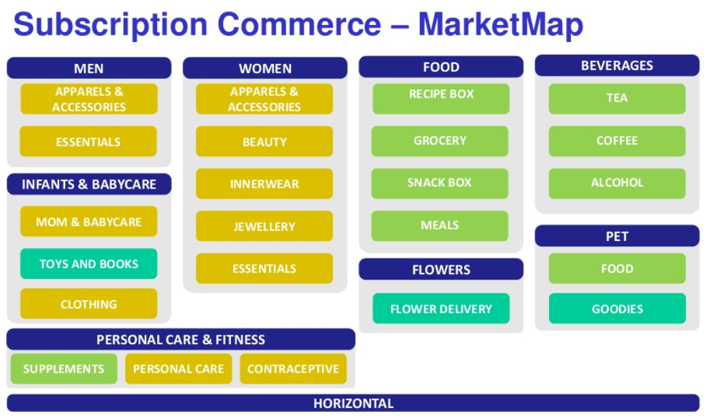

Chart Retrieved from: http://www.slideshare.net/Tracxn/tracxn-subscription-commerce-march-2015

4.4 Market Size Must have an academic definition

4.4.3 Micro Demand Curve Must have an academic definition

4.5 Environmental Models and Analysis

4.6 Alternative Solutions and Disruptive Technologies (if it applies)

5.0 Offerings - TING
http://subscriptionschool.com/guide/key-performance-indicators-subscription-boxes/
KPI

5.1 Description (Products/Services)
The WhatsInTrendBox is a monthly box subscription that includes five to six to full-size non-gmo and/or organic products delivered to your doorsteps. Our company caters to and targets consumers that are health-conscious or are trying to switch to non-GMO and organic products. There are a number of health promoting companies out there - see market research section - however, what distinguishes our product from others is that healthy is not equivalent to non-GMO and Organic. Non-GMO stands for non-genetically modified. Scientists have already identified many health risks associated with consuming GMOs (http://non-gmoreport.com/what-is-non-gmo-what-are-genetically-modified-foods/). Organic, or certified organic, means that the product must be produced without the use of synthetic fertilizers, genetic engineering, sewage sludge or irradiation. Organic foods are free from artificial preservatives and organic growers and handlers must be certified by organizations that are accredited by the USDA (http://www.simpletruth.com/about-simple-truth/organic/).
These products are what separates us from the rest, and our effective marketing strategy will be the reason for customer growth and retention. Our subscription box is both a convenient and more efficient way to browse/try new healthy products on the market without taking a step out of your door!

5.2 Cost to Produce
The WhatsInTrend Box is priced at $24.99/mo. This is charged on a month-to-month basis to the subscribers.
The cost to produce will be at or under $9.79/box in order to generate a 40% profit margin. This is broken down into three parts:
- Acquisition of products - $2.29/box
- Cost of packaging and delivery - $5.20/box - USPS 8 5/8″ by 5 3/8″ by 1 5/8″ small box
- Marketing - $2.29/box
Our company will acquire products through the following methods. Director of Marketing is in charge of cold-calling/e-mailing targeted businesses for samples and building vendor relationship. She is also responsible for purchase name-brand/popular products in bulk to include in our box to elevate the quality of our products.

5.2.7 Manufacturing Hours

5.2.8 Average Labor per XX

5.2.9 Material Cost

5.3 Competitive Advantages/Disadvantages

Table XX – TOWS Analysis
Internal Factors  External Factors | Strengths (S) | Weaknesses (W)
Opportunities (O) | SO Strategies | WO Strategies
Threats (T) | ST Strategies | WT Strategies

6.0 Marketing Strategy - Kelsey
http://www.mysubscriptionaddiction.com/2013/11/how-to-start-a-subscription-box-company.html
useful website

6.1 Target Markets - Based on our primary research conducted with Survey Monkey, our main target customers would be both male and female between the ages of 25 and 44 . These target customers would be people who are already customers of subscription boxes or who are wanting to begin or maintain a healthy lifestyle.

6.2 Market Image Must have an academic definition

6.3 Promotion - Offer a 10% off promotion for new customers to help gain subscribers. Also, partner with participating companies that will have their products in our box to create a special coupon code for our subscribers. If our customers want to directly purchase a full size or large quantity of the sample product offered then they can do so from the company’s website and use the special coupon code to get a better deal.

6.3.1 Image

6.3.2 Publicity - Publicity is the free content about our company that appears in the media. To begin, we will tell family and friends about our new business venture and spread information through referrals and word of mouth. Our company will also set up social media pages for the business (facebook, twitter, instagram, youtube) and invite people to like our pages. To gain more exposure and get our product out there we will encourage people who view our social media pages to share our pages for their friends and family to see. What’s In Trend will utilize the publicity of Twitter by retweeting famous celebrities, reaching out to see if well-known health and fitness influencers on social media want to try a box for free and post it on their IG or social media accounts to promote if they are satisfied with it. Social strategy could be the most powerful channel for creating customer awareness, driving traffic and gaining subscribers to your product. What’s In Trend Box will conduct free giveaways for people who sign up for the subscription and get 3 of their referrals sign up as well. We will give the first month free for anyone who can get 3 or more people from their referral list to sign up. The more content that is on the internet about our product, the better it is for our business. Along with all of the other publicity, blogging is a great way to pull customers by creating a relationship with them and adding value, they can also be shared across social media platforms. We will create and keep up with a blog. On the blog we will talk about all of the new products we will have in our box each month and the benefits that come from them, also our business and any promotions will be mentioned on the blog to entice consumers to visit the blog often. In addition to our social media sites we will post an offer for a 10% off coupon for their first month to motivate customers to sign up. Interact in forums and Q&A websites to get more content on the internet for current and potential customers. forums and Q&A websites such as Quora or Reddit to tell people more about our product and subscription box business. collect emails and build up the email list because it is free and has great potential, if we sent out 20,000 emails with information on our product to people that may be interested in our subscription box then the results could be exceptional.

6.3.3 Advertising - Need to buy 20,000 business/marketing cards to put in the subscription boxes. This will help people stay connected and know our social media sites, hashtags, and blogs. The business cards are $0.03 each from Vistaprint and the highest quantity sold is 10,000. Therefore 20,000 business cards would be $640 for the first year. Other advertising content we could pay for would be radio, tv, newspaper, banner advertising, or pay-per-click advertising. We could set aside money to see how paid advertising does for the company instead of spending a bunch of money up front on advertising since free publicity and word of mouth is our main source for gaining subscribers. For instance, put 20$ a week to Google adwords or Facebook advertisement banners and see what type of traffic that generates. We could utilize Google adwords and Facebook banners for the first 6 months after launching our box and then after the 6 months is up we would analyze our subscription results and see if the facebook or google ad’s have generated a lot of leads; if it has then we can continue paying for this advertising for another 6 months and then solely rely on free publicity after our first year of paid facebook and Google advertising. Create video content to post to youtube, instagram, facebook, or other video media platforms. Have the video show the value and greatness of our product, high quality videos can go viral and give our business an abundance of recognition. Could try out SEO (search engine optimization) and hire a company or individual to help gain traffic and rank or try SEO ourselves to gain website ranking and free traffic.

6.4 Pricing Methodology

6.5 Sales and Sales Cycle

6.6 Channels of Distribution The type of distribution channel we will use is going to be an indirect channel where we purchase and make deals with participating companies to get wholesale prices on their product. We will purchase non-GMO organic products directly from local companies and disperse the products throughout our subscription boxes to then send out to our subscribed customers. We will also ask companies if they’d like to pair with us to create a special promotion code for our subscribers so our customers could order through a direct channel if they like the products and would like to get full-size or more of a certain product directly from the local company.

6.7 Logistics

6.8 Time to Market Analysis - The products we receive will already be packaged in the company’s original packaging and they will be ready to go as soon as we receive the order. All that our staff will need to do is disperse one of each of the products in a box and pair it with the other products from different companies. Once the box is full with all the products from the participating companies and a social business card is placed inside, the box with all the product will be ready to ship out. Therefore, as soon as we receive the product and it is placed in the boxes, it will be shipped at the earliest convenience making the time to market just a couple of days.

7.0 Competitive Analysis

7.1 Competitor Identification and Capabilities Analysis

Our Competitors
1. Graze box
2. Conscious box
3. Vegan cuts
4. Nature box
5. Bestowed
6. Urthbox
Industry rating
- Nature box
- Urthbox
- Graze box
The main competitors in the industry are Nature box, Urthbox and Graze box because they are ranked first, second and third consecutively in the industry due to their already established presence in the market. The major threat comes from Bestowed because they just acquired Conscious box a growing market market share. We need to pay more attention to Graze box because they are growing their company year to year.

Factor | What’s In Box | Grazebox | Healthy surprise |  | Bestowed | Vegan  cuts | Nature box
Price | 24.99 | $11.99 | $49.99 |  | $20.00 | $22.95 | $9.99
raw | ü |  | ü |  | ü | ü
Nutrient-dense | ü | ü | ü |  | ü |  | ü
Plant-based | ü |  |  |  |  | ü
Free from animal products | ü |  |  |  |  | ü
Gluten free | ü |  | ü |  |  | ü
Free from transfat | ü | ü |  |  | ü | ü
Wheat free | ü |  | ü
Weightloss friendly | ü | ü |  |  | ü | ü
Soy free | ü |  | ü
Free from artificial preservatives | ü | ü | ü |  | ü | ü
Dairy free | ü |  |  |  |  | ü
Free from artificial colors | ü | ü |  |  | ü | ü | ü
GMO-free | ü | ü | ü |  | ü | ü
Meets whole foods standards | ü |  |  |  |  | ü

7.2 Detailed Value Index Must have an academic definition

7.3 Competitor Strengths and Weaknesses and Positioning
Graze box-
Graze smartly focuses upon career-oriented people as their target audience. It Is a UK based company started by 7 friends in one of their bedrooms. They produce about 100 snacks. Expanded to the US in 2013. The company distributes thousands of snack boxes per day
Out of 5 consumer surveys rated the
- Service 4.5
- Value 3
- Shipping 4
- Returns 3
- Quality, 5

deliveries are weekly or every 2 weeks or once a month
-4 snack sampler boxes
- boxes contain 8 snacks

Strengths
- No High fructose corn syrup, trans fats, GMOs or artificial ingredients
- Over 100 healthy treats available
- Can get a box every week, every two weeks or once a month
- Free shipping
- box arrives in 10 days for first order
- can pause deliveries when away
- develops its own recipes
- involved in Charity work. Graze sponsors a farm in Uganda called the Graze school of farming that teaches kids how to farm fruit trees
- Graze has you rate the snacks you enjoy in “normal life” and then uses that information to customize your deliveries with four special treats they expect your will love
- additional one time boxes can be ordered

Weaknesses
- The price seems a bit high when you consider the portion size, however, it is being shipped to you so that increases the cost
- 5 of the boxes include 4 snacks which would mean you’d have 1 day per workweek without a snack
- no returns
Pricing
Graze offers 7 different boxes to help you stay on track with your snacking goals while also making your palate happy.

 | Price | # snacks | about
4 snack variety box | $6.99 | 4 snacks | all snacks available
sweet treat box | $6.99 | 4 snacks | sweet treats nutritionist approved
savory box | $6.99 | 4 snacks | savory inspired snacks
calorie count box | $6.99 | 4 snacks | all snacks under 50 calories
sugar count box | $6.99 | 4 snacks | all snakes under 5 grams of sugar
8 snack variety box | $11.99 | 8 snacks | double the snacks
sharing box | $25 | 5 sharing bags | 20 portions of snacks for sharing
Strategies

Network marketing

Graze box is the most successful at this strategy. They entice their customers to market for them. As a customer you can get your friend a first free box and they get the second one at half price. The customer that referred also gets a kickback as their next box is free too. Literally they are sending their army of customers to go sell for them.

Social platforms

These incentives encourage people to talk on facebook and twitter. It even prepares the tweet or status update on the advocate’s behalf, complete with a unique code that ensures they are recorded as making the recommendation and so they get a free box.
Google “Graze boxes” and you’ll see a tonne of blog posts. Unusually for a product, most of the visible comments are positive.

Word of mouth

The army of customers spread the word

Vegan Cuts
Caters to vegetarians
· Porter Novelli’s proprietary survey about consumer attitudes and behaviors, ConsumerStyles, reports that compared to the total population, vegetarians are more likely to be female (62 percent female, 38 percent male), and the average age of vegetarians is 47. Vegetarians are less likely than the total population to be married (49 percent vs. 61 percent), and this group is less likely than the total population to have at least one child under the age of 19 living at home. In addition, vegetarians are more highly educated than the total population, says COnsumerStyles, with 41 percent reporting to have a college education or higher, compared to 32 percent of the total population.

Strengths
- Rest assured that all products are vegan (no animal products)
- Majority of the foods and drinks are gluten free
- Free shipping to the U.S.
- The Snack Box from Vegan Cuts ships within 7-10 vegan foods and drinks inside
- The products vary in size from samples to full size so you can try lots of new items
- They also offer a separate beauty box if you’d prefer to focus on cruelty-free personal care products.
- . Although this is a very diet specific box, it’s a very good option for those of you who are vegan or enjoy eating vegan goodies.
Weaknesses
- Pre selected so you don’t get to select your products
- Does not cater to any allergies other than Vegan. So there is no promise of GMO-free or organic
- Can only be received once a month
- Mix of full and sample size products
The Snack Box from Vegan Cuts includes 7-10 vegan snacks.
- $19.95 for 1 month
- $59 for 3 months
- $115 for 6 months
- $215 for 12 month
Strategies
· Firstly, the goods supplied are often new releases before they are available in shops
· The focus is built around enhancing the knowledge base of their customers
· quality cosmetics that are cruelty-free
· Vegan Cuts collects their knowledge and passion for vegan things and compile this mass of information in a way that doesn’t feel like a web store at all. It’s more like, browsing a well-informed friend’s blog.
Bestowed (Formally Conscious Box)
The products included are more than just food,but all aspects including the products you use on your skin and the products you use to clean your home.
Strengths
- GMO-free
- Vegan and gluten free options
- Includes food, bath, beauty and home products
- Supports fair trade businesses
- Free shipping
- Bestowed lets test products and purchase the ones you love
Weaknesses
- Not well suited for office snacks
- Not snack specific but covers all aspects of health and beauty
pricing
1 month $20
3 months $18
6 months $17
12 months 16

Strategies

Targeting health-conscious women
- When Ross started using Facebook, he updated Bestowed’s Page 1-2 times a day. He kept up a regular dialogue with customers to get product feedback and posted vibrant photos of the latest box.
- After ongoing ad testing with News Feed ads, Ross quickly realized the benefit of using precise interests targeting and Facebook’s conversion tracking to measure their ad return. He was able to find Bestowed’s existing customers by using custom audiences to upload the company’s past and current membership lists.
- He also used lookalike audiences to target people similar to their existing members.
- Ross placed his ads in both mobile and desktop News Feed, and discovered that most customers were visiting the Bestowed website from mobile devices.
- He used that information to target mobile device owners, and saw a jump in conversions from those ads.
- In addition to looking for new customers, Ross also invests in reaching out to people that have visited the company website in the past. He uses Facebook Exchange to retarget these people, and encourage them to return to the Bestowed site.
Success Story
Delivering healthy food options
Online health food delivery service uses Facebook to grow its subscriber base and drive online sales with a 5X return on ad spend.
- 5X return on ad spend
- 30%increase in website traffic from Facebook Ads
- 2Xhigher new customer conversion rate on Facebook (compared to other online advertising channels)
- 20%lower cost per click on Facebook Ads (compared to other online advertising channels)

Ross and Heather wanted to use Facebook Ads to draw attention to their service and drive new subscriptions and sales. They wanted to cost-efficiently target health-conscious women aged 25-44 living in the United States.
Facebook is a critical part of our marketing mix. I initially didn’t realize how good Facebook was for targeting specific groups and interests. The best part is that it was inexpensive and easy to set up, and provided immediate returns. This is why we chose to use Facebook as our primary marketing channel instead of other competing channels.
Ross Bauer, Co-Founder, Bestowed
https://www.facebook.com/business/success/bestowed
Nature Box
Strengths
- More than 100 snacks to choose from
- Free trial offers 5 snacks
- Choose which snacks are in your box
- Bigger portions
- No hydrogenated oils, added sulfites and artificial colors, sweeteners and flavors
- Less than 200 calories per 30g serving
- For every box delivered they donate one meal via Feeding America to help hungry Americans
- Receive a box biweekly, monthly, bimonthly or every three months
- Option to skip a month
- Free shipping
- NatureBox also offers several sizes of Office Boxes so you can share healthier snack options with your colleagues
- Naturebox offers a free trial where you are able to get five snacks for free and you can cancel at anytime.
Weaknesses
- Packaging doesn’t allow you to see the product inside so you don’t know exactly what’s in the pouch
- In 2013, there were several complaints about customer service and product quality
Pricing
 | Free trial | Monthly | 3 months | 6 months
price | $2 ( for shipping) | $19.95 (shipment | $17.95 (shipment) | $16.95 (shipment)
# of snakes | 5 pre-selected snack size | 5 snack bags | 5 snack bags | 5 snack bags

Urthbox
Located in San Francisco and available in the US and Canada only at the moment
UrthBox ships once a month. These boxes are premade, so they cannot be customized based on your likes or dislikes. However,

Strengths
- Classic, gluten free, vegan and diet options
- Organic and no GMOs
- Receive points for each box you get and redeem them on the site
- Offers many different monthly box sizes
- Free shipping to U.S.
- UrthBox offers one main box at different sizes, so depending on how many snacks you want for the month you can choose the size that is right for you.
- They also offer an Office Box to be shared with your company.
- Provides coupons
Weaknesses
- Only sent once a month
- Can’t choose the snacks
- Bad customer service
- Difficult to cancel
- No renewal notice and no immediate refund
- do not offer the ability to order such customizable boxes

Pricing
 | Price/month | Price for 3 months | Price for 6 months | # of products | Group size
Mini | $19.99/month | $14/month | $9/month | 4-5 | 1
Small | $29.99/month | $24/month | $19/month | 8-10 | 1
Medium | $39.99/month | $34/month | $29/month | 14-16 | 1
Large | $59.99/month | $54/month | $49/month | 20-24 | 1
Office box | $199.99/month | N/A | N/A | 100+ full size products | 5-10

Strategies
- UrthBox has Partnered with Affiliate Companies, Versa Marketing and ShareaSale
- Gives $10 off your first box
- Gives $10 credit for referring a friend
- Advertise through other sites like groupon

 |  | WHATTSINN | GRAZEBOX | HEATHY SURPRISE | BESTOWED |  | VEGAN CUTS | NATURE BOX
OVERVIEW AND PROFILE
COMPETITIVE ADVANTAGE
TARGET MARKET
MARKET SHARE
MARKETING STRATEGIES
PRODUCTS AND SEERVICES
PRICING AND COST
DISTRIBUTION CHANNELS
STRENGTHS
WEAKNESSES
OPPORTUNITIES
THREATS

8.0 Development Program
Growth in the company is expected, however forecasting and planning is not necessary in the beginning. The goal for development in years 1-5 is to grow the number of subscription sales. As What’s In Trend Box begins to grow in popularity, further planning for development will be discussed and implemented.

8.1 Objectives-

The main focus is on short term goals. Learning and development is an ongoing and active process. This is to prevent knowledge and skills from becoming obsolete within a few months. Quarterly improvement goals and strategies for business development are discussed and implemented by partners through weekly staff meetings. Development programs are not set in stone. Change equals progress and opportunities to expand the business are assessed as they come up.

8.2 Schedules-

Years 1-5:

Months 1-2: Recruit members and gather products.
- The 11th - 31st: Following month’s orders are accepted.
- The 20th - 25th: Final product agreements completed, rough quantities given.
- The 1st: Based on predicted numbers of orders to come in over next 10 days, planned quantity decided. Product ordered from participating brands.
- The 1st-10th: More current month orders are accepted assuming there is still available product.
- The 12th-15th: Product arrives and is shipped out to subscribers! (Cadman, 2013)

8.3 Technology -

Subscribers are managed through an online platform, Wordpress WooCommerce, in combination with PayPal to collect membership dues. At shipping time each month, subscribers files are downloaded and then uploaded into a shipping management program (Endicia for Mac). Afterwards, labels are printed out in bulk using a Zebra LP2844 printer then affixed onto shipping materials. Endicia for Mac also allows us to send out professional looking tracking e-mails to subscribers. (Cadman, 2013)

Zebra LP2844 printer ($249.99) http://www.ebay.com/p/Zebra-LP-2844-Label-Thermal-Printer/48450211

Endicia for Mac ($15.95 per month plus cost of postage) http://mac.endicia.com/?referredby=wmc8&gclid=CLfJmtbQp8sCFZA2aQodmgwFPA

8.3.2 Resale of Inventory -
Any leftover non-perishable inventory from previous months will be stored for the following year. To avoid sending out the same items to subscribers twice in one year, inventory from previous months will not be included in the boxes of months closely following.

9.0 Operations / Production

9.1 Organization / Staffing Plan

What’s In Trend Box staff share financial and operational responsibilities within the organization. Duties are assigned on an “as-need” basis and can transfer from partner to partner, depending on sales forecasts for the upcoming month. Volunteers from outside of the organization may be recruited if additional help is required.

9.1.1 President / CEO - Ting
Ting, President of What’s In Trend Box, has ultimate responsibility for planning, innovation, implementing, and integrating the strategic direction of the company. This includes vendor communications as well as workforce management. Ting will make certain that the leadership of the organization is aware of both internal and external competitive opportunities for expansion, customers, markets, developments, and so forth. (Heathfield, 2016) Ting also shares in the responsibility for replying to executive level customer compliments, suggestions, and complaints.

9.1.3 Production Staffing - Josie, Ray, Caio, Kelsey, Chelby, and Tina:

Customer Service: Josie, Ray, Caio, and Chelby depending on availability.

- Main responsibilities include responding to customer compliments, complaints, and suggestions. All customer emails and voicemails require action within 24 hours. If the customer writes an email, we will respond with a phone call, if possible, for customer satisfaction.

Packaging (Fulfillment) - Josie, Ray, Caio, and Chelby on rotating shifts.

- Main responsibilities include final quality assurance, adhering to consistent proper packaging techniques, and making sure that products are received by subscribers in excellent condition.

Shipping - Josie, Ray, Caio, and Chelby depending on availability, on rotating shifts.

- Main responsibilities include managing the shipping management program Endicia for Mac, corresponding with the carrier, responding to lost in transit inquiries from subscribers, receiving product, and mailing boxes.

9.1.5 Marketing and Sales -
Kelsey, Director of Marketing and Sales, main responsibilities include brand awareness, business expansion, public relations, sales forecasting, and new market research. Social strategizing is especially important for making new product and customer connections.
9.1.6 Accounting and Finance -

Tina, Accounting and Finance, main responsibilities include administration, bookkeeping, payroll, taxes, refunds, etc.

9.2 Suppliers

Finding new supplier opportunities is a shared responsibility of all partners.
9.2.1 Equipment Providers -

Packing materials are provided by FedEx in Years 1 and 2. Once profit margins are met, packaging will be designed for the upcoming quarter. Branded packaging supplier is to be determined and may be subject to change depending on availability, sales volume, and cost that year. FedEx supplies packaging as part of their volume shipping membership, which cuts costs, however limits brand awareness and recognition. Distributing branded packaging is the long term goal.

9.2.2 Material Providers -
Various local Texas owned and operated businesses will donate samples and sell us small sized products to distribute to subscribers. The company will try to purchase products at wholesale prices from local vendors, if possible. Occasionally the company may pay full price for other items, which offsets limiting the brands inside of the box. However, purchasing products at wholesale prices is essential to earning a profit.
New product providers come from a variety of sources, direct emails from brands, suggestions from subscribers, and in-house searching (attending natural product trade shows, searching in online directories, etc.) (Cadman, 2013)

9.4 Quality

9.4.1 Methodologies -
Quality Assurance is done through keeping all operations in-house. The entire process is streamlined from the receipt of an order, to dispatch, and later to shipment. Product decisions are most often well-planned. Bonds are formed and negotiations are made 2-3 months in advance. (Cadman, 2013) Efforts are made by all shareholders to make connections with potential product by sending out well-written e-mails or making a phone call to a sales or marketing director. Whether that connection be made through word-of-mouth, research, or referral, only the best will be included in the box. Quality is checked throughout the supply chain. Selection of product is determined by price, availability, and overall alignment with company vision. Once the product has been selected it will be booked for the following month(s).

9.5 Inventory

9.5.1 Work in Process-

9.6 Training
Quality assurance training for fulfillment and customer service may be implemented in the future. However, no formal training is required by partners in the company years 1 through 5. Shareholders are accountable for demonstrating integrity within their roles to the business. As the company grows, formal trainings in business conduct will also be established.

9.6.1 HR Required-
When our company starts making substantial profits we will add an HR department. For now, our Accounting/Finance department is responsible for employment benefits and CEO/President for team bonding and communication.

10.0 Investment Capital

10.1 Initial Funding - Sources
-Contributed capital from capital business owners..Initial funding projection is $-------------- @ $------------a piece from 7 owner contributors.

10.2 Use of Funds

Start-up Cash In
Borrower equity
REAP Loan
Bank Loan
Total Cash In | 0
Start-up cash out
Purchase equip & supplies
Purchase Inventory
Total Cash out | 0
Beg working capital | 0

10.3 Return on Investment (ROI)
(Total Revenue-Total Cost / Total cost) X 100

10.4 Enterprise Value Calculation
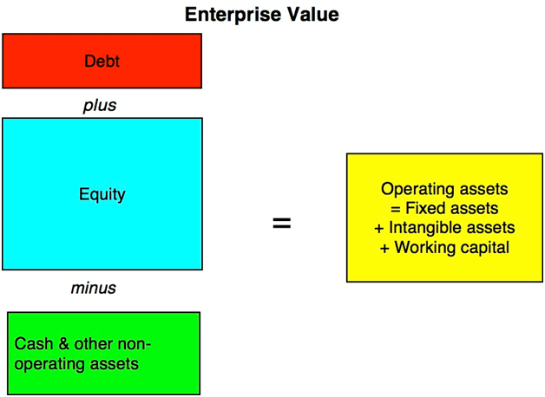

10.5 Break-Even Analysis
BES = FC/(P-VC)

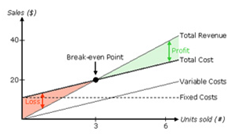

11.0 Financial Projections

http://start.cratejoy.com/subscription-box-calculator/ - just plug in our numbers and it wil show you a graph with projected sales on the bottom of the page.

https://www.zuora.com/guides/subscription-finance-basics/ (Tina I hope this helps you - Caio)

11.1 Year One Through Five Income/Expense

11.2 Year One Through Five Cash Flows

11.3 Year One Through Five Balance Sheets

12.0 Financial Alternatives

12.1 Expected Case

13.0 Financial Addenda

13.1 Assumptions

13.2 Ratios

13.2.1 Liquidity Ratio

13.2.2 Profitability Ratio

13.2.3 Leverage Ratio

14.0 Financial Charts

15.0 Risk Analysis
The SWOT analysis identifies XXX
Table 29 – SWOT Analysis
Strengths (S) | Weaknesses (W)
Opportunities (O) | Threats (T)

16.0 Resumes of Key Players
Conclusion

17.0 Appendices

Appendix A – Cost of Harness

Appendix B – Timeline

Appendix C – Income Statement

Appendix D – Cash Flow

Appendix E – Balance Sheet

Appendix F – Fully Burden Labor

Appendix G – Assets and Operating Expenses at Startup

References
Cadman, L. (2013, November 1). Starting A Subscription Box Company – All Your Questions Answered! Retrieved March 13, 2016, from http://www.mysubscriptionaddiction.com/2013/11/how-to-start-a-subscription-box-company.html
Josie - 8.2 Schedules, 8.3 Technology, 9.2.2 Material Providers, and 9.4.1 Methodologies

Ferrell, O. C., & Hartline, M. (2012). Marketing strategy, text and cases. Nelson Education.
Caio - 4.0 Market Segmentation

Heathfield, S. M. (2016, February 14). What Does a Chief Executive Officer Do at Work? Retrieved March 13, 2016, from http://humanresources.about.com/od/job-titles/f/Chief-Executive-Officer-Ceo-Do.htm
Josie - 9.1.1 President/ CEO

