Case 11

Supply Chain Management at Dream Beauty Company
Dream Beauty (DB) Company is a manufacturer of consumer beauty supplies and cosmetics. Based out of Money City, Nevada, the company services its customers across the U.S. Recently, a supply chain expert was elected to the board of directors. With his insight into supply chain operations, heightened attention was turned toward that area. The costs in this area have been increasing, and management became very concerned about the issue. The company annual sales reached $130,000,000 for the first time since inception. Management believed that some of the increase in supply chain costs may be attributed to additional sales, but they were confident that other factors existed that needed to be addressed. The situation had management’s full attention, especially since supply chain costs (and savings for that matter) flow directly to the bottom line.
DB supplies its products through three distinct channels: retail stores (direct), convenience stores, and mass merchants. Each channel is considered an independent profit center with full financial responsibilities for income statement and balance sheet. From DB sales, retail accounted for 50 percent, convenience stores for 30 percent, while mass merchants picked up the remaining sales. Cost of goods sold accounted for 40 percent of sales. All three channels seem to be profitable, and contribute equally to DB, according to the company’s cost accountant.
The order fulfillment cycle at DB consists of four areas:
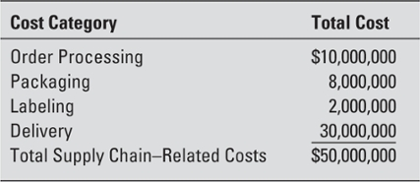

The total order fulfillment averages three days. All orders are processed through a central location, and delivered from distribution centers located across the U.S. Usually retail and convenience store orders are shipped unlabeled on standard nonmixed pallets. Mass merchants, on the other hand, have placed a lot of pressure on DB and want the company to take an active role in helping them manage their inventory. To accommodate this channel, DB has assumed some of the jobbers’ functions in the store and started labeling the orders for mass merchants. To accomplish that, the company recently purchased a labeling machine that can process labels at a speed of 30 labels/second. The machine’s historical value was determined to be $10,000,000. The company usually depreciates similar equipment on a straight-line basis over a period of five years.
The company has a discount policy for all three channels that it services. The net is due in 30 days. While this policy is explicitly stated on all DB’s invoices, retail stores are the only ones that pay according to invoice terms. Mass merchants usually pay within 15 days, while convenience stores usually pay within 45 days. The company’s cost accountant reported that all sales were sold on credit. Cash sales and C.O.D. sales were rare; therefore, they can be ignored for the purpose of this analysis. DB does not engage in any barter transactions.
The company received a total of 3,600 orders. Retail orders amounted to 1,000; convenience stores to 2,500; and mass merchants had 100 orders. Each order has a corresponding delivery that is usually completed within the three-day fulfillment cycle. The company’s practice has been to allocate logistics-related costs to its three channels based on their relative percentage of sales volume. The orders were shipped in 2,000 packages, with retail accounting for 800 packages, convenience stores for 1,100 packages, and mass merchants for 100 packages. Packaging cost is estimated to be the same regardless of size. To service these orders, the company has maintained an inventory safety stock so that it can meet the level of service that it promises its customers (the three-day fulfillment cycle). It is estimated that the company holds an average of 90 days’ inventory for retail, 60 days’ inventory for convenience stores, and 40 days’ inventory for mass merchants. The company’s cost accountant estimated the total carrying costs of inventory to be approximately 15 percent of total average annual inventory. These costs also include the cost of capital.
The company’s customer base in convenience stores includes 13 different stores located in major U.S. cities. Table 1 provides a breakdown of sales per store, as well as the number of orders, and packages for each store.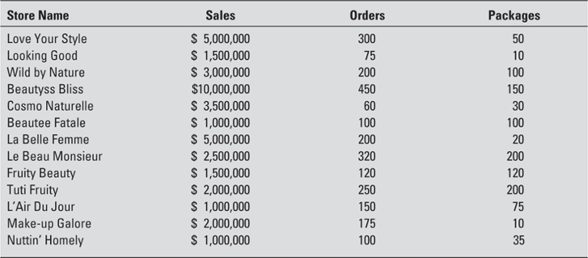
Table 1 Activity Summary by Account
Historically, DB has offered its customers a level of service that is of the highest standards. One of the fulfillment managers has been quoted, “We do not discriminate between customers; our three-day fulfillment cycle in my opinion is becoming an industry benchmark, and I like it that way. I do not think that our strategy should change in that regard.”
The board has some second thoughts about this strategy, and what type of value-added it is generating to the company.
On your first day, you get accustomed to your surroundings, and you become familiar with the computer system. On your second day, the vice president for supply chain (and your hiring manager) comes up to you. He proceeds to brief you on a high-level meeting that he just concluded with the top brass at the company. He states that management wants to know why supply chain costs seem skewed, as well as a full analysis of the three logistical channels that the company employs. Management would like you to answer the following questions.

Questions
- Analyze the way that current costs are being allocated; what potential changes can you recommend to make the system more efficient and more accurate?
- What is the profitability level and return on investment by distribution channel, under both the current and the recommended allocations?
- What are your recommendations regarding the company policy of offering all its customers the same service level (three-day fulfillment cycle)?
Note: The company’s cost of capital for both borrowing and lending can be estimated at 9 percent. Ignore tax effects on all transactions.

