Group One: Facebook
Describe the company structure of Facebook. Then, research and present the six main Human Resource functions of Facebook. Pick one function of the functions in which there is room for improvement and suggest how you would improve the function to make the company better. Here are the functions:
- Human resource planning, Recruiting, selecting, and compensating of employees
- Providing employee benefits
- Appraising employee performance
- Training and developing employees
- Dealing with labor relations (i.e., union) issues
You should prepare a 5 page report (1000 words) and 8 slide power point presentation.
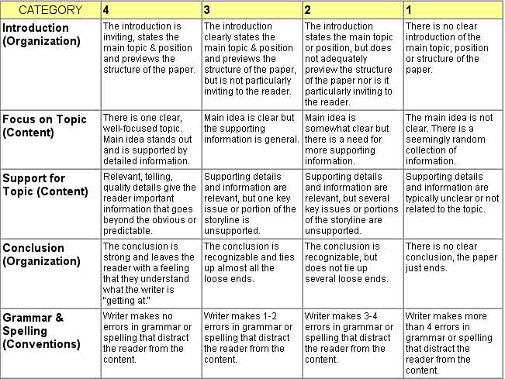

Group Two: Uber
Describe the company structure of Uber. Then research and present the six main Human Resource functions of Uber. Pick one function of the functions in which there is room for improvement and suggest how you would improve the function to make the company better. Here are the functions:
- Human resource planning, Recruiting, selecting, and compensating of employees
- Providing employee benefits
- Appraising employee performance
- Training and developing employees
- Dealing with labor relations (i.e., union) issues
You should prepare a 5 page report (1000 words) and 8 slide power point presentation.

