Case Studies Week 4
Karen L. Campbell
South University Online
Instructor Chapin
Business 3055

Case Studies Week 4
Case Study 1: Bankruptcy
Andy unfortunately, has come upon a time in his life that for unseen reasons, the world has caught up with him. The decision to declare Bankruptcy cannot be taken lightly. The main reason for bankruptcy is to relieve a person of debt and, to provide a fresh start by liquidating debt and to keep creditors through a bankruptcy court to deal with the debtor so that no one creditor prevails at the expense of the other creditors. Chapter 7 wipes the slate clean (Twomey & Jennings, 2013)
Andy’s income has dramatically been reduced by half from 80,000 to 40,000 a year and due to unemployment he could not keep his obligations to pay his mortgage, and pay his credit cards and his education and custodial duties of child support. Andy resides in Florida and his income under the Bankruptcy Abuse Prevention and Consumer Protection Act of 2005 (BAPCPA) require a means test to determine if his income is low enough to file, he would be able to meet the criteria (thismatters.com). The means test takes into account the Standards Administrative Expense Multipliers and IRS’s National Standards for Allowable Living Expenses and Local Standards for Transportation and Housing and Utilities. Under the State of Florida, the income standards are 41,000 to 58,000 (justice.gov.)
Andy’s honesty and actions would come into play, did he make attempts to pay or were his unemployment the main reason along with his reduced income and his obligations that would not be discharged such as child support and student loans. The information in this scenario was unclear but if advising Andy by filing chapter 7 would not relieve him of the education loan debt and child support obligation.
—
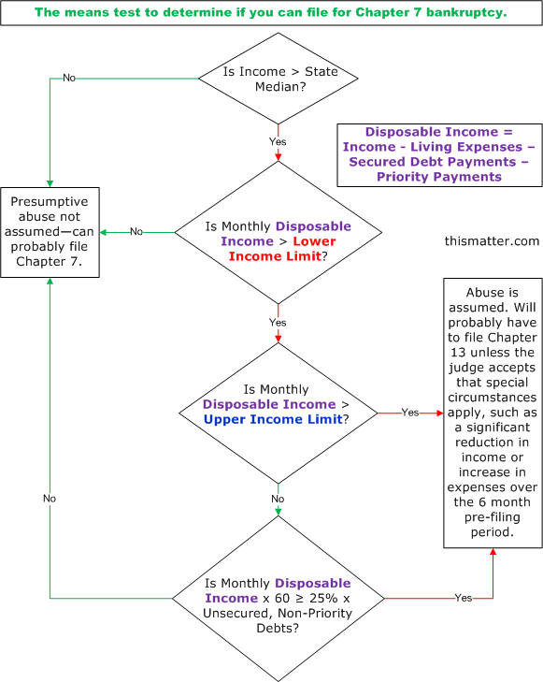
Suppose using BAPCPA calculating Andy’s income are 3, 333.00 per month – allowable expenses under the code 1029.00 plus education loan amount of approximately 100.00 per month plus 300.00 child support plus housing in Brevard county 1029.00, car 450.00, health insurance cost 200.00 = 3108 allowable expenses ;
Current monthly of $3,330.00 – 3108.00= 222.00 x 60 = $13,320.00. Andy would meet the means test and can proceed because his unsecured debts are more than $13,320.00 his are $15,000 (SUO, 2013).

Case Study 2: Insurance
Franco as the owner of the Piazza Pub is liable for his employee accident having allowed Chris to drive his personal vehicle on company time. The grounds for a lawsuit could be argued that Franco as manager was negligent in loaning the car to a 17 year old with little experience. Franco should have known that the employee Chris was not trained, and his lack of experience to drive the car for “which liability would be imposed under the doctrine of respondeat superior was a negligent act committed within the scope of employment” (Twomey& Jennings, 2013).
Respondeat superior is the doctrine that states that an employer is responsible for an employee. More precisely, it states that a master is liable for torts of its servants committed in the course of their service or under the “Scope of Employment” (Greenwood, 2013)
Recommendations for Franco to reduce his liability for negligently lending of a vehicle he should: (1) draft and enforce a vehicle policies that requires as the employer to have documentation on file. (2)Obtain adequate insurance on all vehicles. (3) Ask your insurance agent about vehicle safety programs and make sure all employees attend (Twomey & Jennings, 2013).

Reference

Daniel J.H. Greenwood - Hofstra People. (n.d.). Retrieved from http://people.hofstra.edu/Daniel_J_Greenwood/Courses/Torts/RespondeatSuperior.ht
Http://www.justice.gov/ust/eo/bapcpa/meanstesting.htmReferences
The Means Test In Bankruptcy—Is There A Presumption Of Abuse? (n.d.). Retrieved from http://thismatter.com/money/credit/bankruptcy/chapter-7/means-test.htm
South University Online. (2013). BUS 3055: Business Law for Commercial Transactions: Week 4: Bankruptcy. Retrieved from myeclassonline.com
Twomey, David P., Jennings, Marianne M.. (2013-03-04). Anderson's Business Law and the Legal Environment, Comprehensive Volume, 22nd Edition. Cengage Learning. Retrieved from <vbk:9781285696683#outline(25.3.5

