Part 1 short answers: just a few lines for each

- What is the problem with marginal cost pricing in the natural monopoly situation? How do regulatory agencies in the United States usually handle the problem?

- What is oligopoly? How does oligopoly differ from the other kinds of market structure?

- Why do firms form a cartel? How do cartels achieve their goals?

- How does a monopoly maximize profits? What price does it charge?

- Explain the three types of goods: search goods, experience goods and credence goods. What type of advertising would firms likely use for each type of good and why?

Part 2:

Multiple choice questions

Question 1 (2 points)

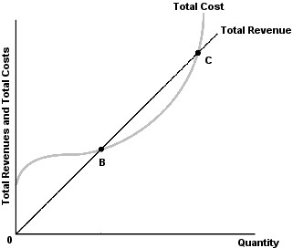
Refer to the above figure. Profits for this firm are negative
Question 1 options:
A) | only for all points less than B.

B) | only at points B and C.

C) | for points between B and C.

D) | for all points less than B and greater than C.

Save

Question 2 (2 points)
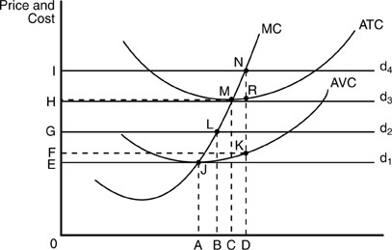
In the above figure, if the firm is facing demand curve d₂, then to maximize profits it will produce at output level
Question 2 options:
A) | A.

B) | B.

C) | C.

D) | D.

Save

Question 3 (2 points)
A firm earning economic losses should operate in the short run as long as
Question 3 options:
A) | the price per unit sold is greater than the average fixed cost per unit produced.

B) | the price per unit sold is greater than the average variable cost per unit produced.

C) | marginal revenue is at least the price per unit sold.

D) | the price per unit sold is equal to or greater than the marginal cost of production.

Save

Question 4 (2 points)
In the above figure, assume d₃ is the demand curve faced by this firm. Which is true?
Question 4 options:
A) | This firm is earning an economic profit.

B) | This firm is experiencing an economic loss.

C) | This firm is breaking even.

D) | This firm's total revenues equal HRD0.

Save

Question 5 (2 points)
The profit-maximizing level of output for a firm occurs at the point at which
Question 5 options:
A) | P = ATC.

B) | P = AVC.

C) | MR = MC.

D) | MR = ATC.

Save

Question 6 (2 points)
In a long-run equilibrium, a perfectly competitive firm's average total cost is
Question 6 options:
A) | minimized.

B) | maximized.

C) | zero.

D) | equal to average fixed cost.

Save

Question 7 (2 points)
Signals are
Question 7 options:
A) | used by economic decision-makers to inform others about their plans.

B) | the method by which government planners inform economic decision-makers about the types of decisions they should make.

C) | the method by which firms determine their profit maximizing quantity.

D) | compact ways of conveying to economic decision makers information needed to identify industries where more resources are needed.

Save

Question 8 (2 points)
For a firm in a perfectly competitive industry, the demand curve for its own product is
Question 8 options:
A) | horizontal.

B) | vertical.

C) | upward sloping.

D) | downward sloping.

Save

Question 9 (2 points)
Refer to the above figure. Profits for this firm are positive
Question 9 options:
A) | only for all points less than B.

B) | only at points B and C.

C) | for points between B and C.

D) | for all points less than B and greater than C.

Save

Question 10 (2 points)
A firm is currently producing at the point where MC = MR. The situation for the firm at this point is P = $5, Q = 100, ATC = $6, AVC = $4.50. What do you recommend this firm do?
Question 10 options:
A) | Increase production above the current output rate, because MC = MR at this rate of output.

B) | Continue to produce the current output rate, because P > AVC.

C) | Shut down, because AVC > P.

D) | Shut down, because ATC > P.

Save

Question 11 (2 points)
A perfectly elastic long-run supply curve indicates
Question 11 options:
A) | a decreasing-cost industry.

B) | a constant-cost industry.

C) | an increasing-cost industry.

D) | that some input prices change as firms enter and exit the industry.

Save

Question 12 (2 points)
One problem associated with a monopoly firm is that it
Question 12 options:
A) | produces too little output but also charges a low price.

B) | produces too much output and charges too low a price.

C) | restricts output and charges a relatively higher price than a purely competitive firm.

D) | is just as good as a purely competitive firm in terms of output and price.

Save

Question 13 (2 points)
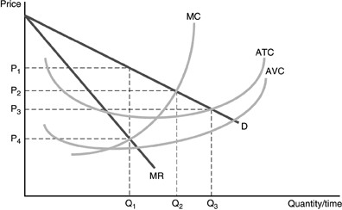
Refer to the above figure. The profit-maximizing price and output for this monopolist are
Question 13 options:
A) | a price of P₁ and output of Q₁.

B) | a price of P₄ and output of O₁.

C) | a price of P₂ and output of Q₂.

D) | a price of P₃ and output of Q₃.

Save

Question 14 (2 points)
To sell more units, a monopolist
Question 14 options:
A) | simply moves across its horizontal demand curve to a larger quantity.

B) | moves down its demand curve to a lower price that will increase quantity demand.

C) | can continue to receive the same price it always has as long as it has its customers' goodwill.

D) | must be willing to lower the barriers to entry that have protected it.

Save

Question 15 (2 points)
If a monopolist wants to increase the amount it sells, it
Question 15 options:
A) | will keep the price the same.

B) | must lower the price on all units.

C) | must accept lower profits.

D) | must lower the cost of production.

Save

Question 16 (2 points)
Which of the following is NOT a barrier to entry?
Question 16 options:
A) | Patents

B) | Licenses

C) | Economies of scale

D) | U.S. antitrust legislation

Save

Question 17 (2 points)
The monopolist determines the price and quantity combination that maximizes short-run profits by
Question 17 options:
A) | finding the quantity at which marginal cost and marginal revenue are equal and then using the demand curve to find price.

B) | determining the price by finding the highest price at which sales can be made and then using the demand curve to find the appropriate quantity.

C) | finding the point at which marginal revenue and demand intersect. This gives the price and quantity that maximizes profits.

D) | finding the quantity at which average revenue and average total cost are furthest apart.

Save

Question 18 (2 points)
Establishing different prices for similar products to reflect differences in marginal cost in providing those goods to different groups of buyers is
Question 18 options:
A) | price discrimination.

B) | cost-plus pricing.

C) | price differentiation.

D) | product differentiation.

Save

Question 19 (2 points)
Price discrimination is the
Question 19 options:
A) | refusal by a firm to sell to all customers.

B) | selling of a given product at more than one price when the price differences reflect cost differences.

C) | pricing of a product so that not everyone can afford it.

D) | selling of a given product at more than one price when the price difference is unrelated to cost differences.

Save

Question 20 (2 points)
The portion of consumer surplus that no one in society is able to obtain in a situation of monopoly is known as
Question 20 options:
A) | a market failure.

B) | a deadweight loss.

C) | an unrealized loss.

D) | a market externality.

Save

Question 21 (2 points)
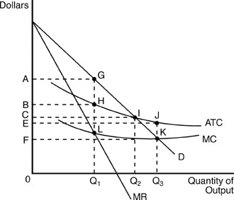
In the above figure, the area of rectangle ABHG represents the monopolist's
Question 21 options:
A) | maximized economic profits.

B) | maximized total revenue.

C) | average total profits.

D) | total costs.

Save

Question 22 (2 points)
If Japanese producers sell computer chips at a higher price in the United States than in Japan, and if there is no cost difference in producing or transporting the chips, the Japanese producers would be practicing
Question 22 options:
A) | cartel pricing.

B) | price discrimination.

C) | simple monopoly behavior.

D) | price sampling.

Save

Question 23 (2 points)
When a firm relies on radio and TV ads to reach potential customers, the firm is engaging in
Question 23 options:
A) | direct marketing.

B) | mass marketing.

C) | interactive marketing.

D) | None of these.

Save

Question 24 (2 points)
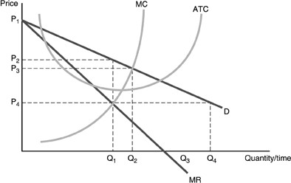
Refer to the above figure. The profit maximizing price for a monopolistic competitor is
Question 24 options:
A) | P₁.

B) | P₂.

C) | P₃.

D) | P₄.

Save

Question 25 (2 points)
The type of advertising that emphasizes the features of its product is
Question 25 options:
A) | informational advertising.

B) | persuasive advertising.

C) | search advertising.

D) | experience advertising.

Save

Question 26 (2 points)
A good that people must actually consume before they can determine qualities is called
Question 26 options:
A) | a credence good.

B) | a search good.

C) | an experience good.

D) | a persuasive good.

Save

Question 27 (2 points)
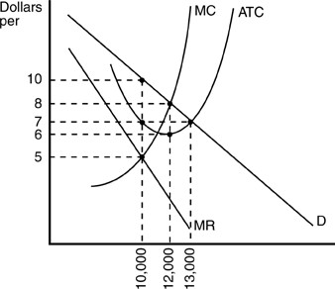
In the above figure, the profit-maximizing monopolistically competitive firm will
Question 27 options:
A) | make a profit of $24,000.

B) | make a profit of $30,000.

C) | make a profit of $0.

D) | incur a loss of $20,000.

Save

Question 28 (2 points)
Interactive marketing is
Question 28 options:
A) | advertising that permits a consumer to follow up directly by searching for more information and placing direct product orders.

B) | advertising that targets a specific audience and allows the consumer to follow up directly by placing direct product orders usually through television or radio.

C) | advertising targeted at specific consumers.

D) | advertising intended to reach as many consumers as possible.

Save

Question 29 (2 points)
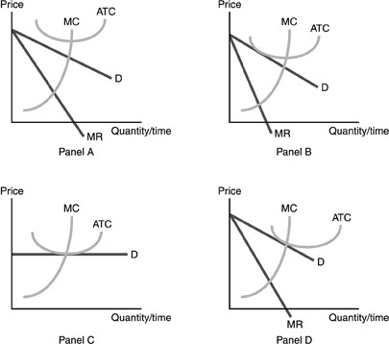
Refer to the above figure. Which panels represent long run equilibrium for the perfectly competitive firm and monopolistic competitive firm, respectively?
Question 29 options:
A) | Panel C & Panel A.

B) | Panel C & Panel B.

C) | Panel B & Panel C.

D) | Panel C & Panel D.

Save

Question 30 (2 points)
A good with qualities that consumers lack the experience to assess without assistance is called
Question 30 options:
A) | a credence good.

B) | a search good.

C) | an experience good.

D) | a persuasive good.

Save

Question 31 (2 points)
A market with few sellers, some influence over price, high barriers to entry, a differentiated product, and non-price competition is known as
Question 31 options:
A) | perfect competition.

B) | monopolistic competition.

C) | oligopoly.

D) | monopoly.

Save

Question 32 (2 points)
A reaction function is
Question 32 options:
A) | companies colluding in order to make higher than competitive rates of return.

B) | the manner in which one oligopolist reacts to a change in price made by another oligopolist in the industry.

C) | a game in which firms will not negotiate in any way.

D) | when plans made by firms are known as game strategies.

Save

Question 33 (2 points)
Which of the following best describes the Battle of the Sexes?
Question 33 options:
A) | Two firms choose incompatible product formats.

B) | Two firms choose one compatible product format.

C) | Two firms wish to coordinate on one compatible product format but cannot agree on which one.

D) | Two firms choose to engage in a noncooperative game.

Save

Question 34 (2 points)
A cartel is a form of
Question 34 options:
A) | collusion.

B) | vertical merger.

C) | noncooperative competition.

D) | negative sum game.

Save

Question 35 (2 points)
Which of the following is NOT a common characteristic of oligopoly?
Question 35 options:
A) | strategic dependence among firms in the industry

B) | product differentiation

C) | barriers to entry

D) | marginal cost pricing.

Save

Question 36 (2 points)
If three firms of similar sizes join to form a cartel, then it is most likely that
Question 36 options:
A) | they will charge a common, higher market price.

B) | they will collectively produce more than before.

C) | all three firms will stop producing.

D) | all three firms will earn zero profits.

Save

Question 37 (2 points)
The prisoner's dilemma shows that
Question 37 options:
A) | players are better off if they act independently.

B) | monopolies are beneficial to society.

C) | people will always cheat.

D) | players would be better off if they cooperated.

Save

Question 38 (2 points)
In which market structures is the firm able to earn long-run economic profits?
Question 38 options:
A) | Perfect competition and monopolistic competition.

B) | Monopolistic competition and oligopoly.

C) | Oligopoly and monopoly.

D) | Monopolistic competition, oligopoly and monopoly.

Save

Question 39 (2 points)
One problem that might occur as a result of economic regulation is
Question 39 options:
A) | the firm may be earning more than a normal rate of return on investment.

B) | the quality of service might be lowered.

C) | that social regulation may follow.

D) | the demand for the good may be greater than the supply.

Save

Question 40 (2 points)
Which of the following statements about natural monopoly is correct?
Question 40 options:
A) | Governments regulate natural monopolies in order to ensure that costs of production are minimized.

B) | Governments regulate natural monopolies in order to ensure that the firm earns a normal profit.

C) | Governments regulate natural monopolies in order to prevent them from making profits.

D) | Governments regulate natural monopolies in order to keep their workers from earning wages that are too high.

Save

Question 41 (2 points)
When consumers have less information about a product than do sellers, then this is the situation of
Question 41 options:
A) | asymmetric information.

B) | symmetric information.

C) | caveat emptor.

D) | a market failure.

Save

Question 42 (2 points)
For a firm to be economically efficient from society's point of view, it should produce to the point at which
Question 42 options:
A) | marginal cost equals marginal revenue.

B) | marginal cost equals average total cost.

C) | marginal cost equals price.

D) | average total cost equals price.

Save

Question 43 (2 points)
U.S. government regulation of social and economic activity
Question 43 options:
A) | only began after World War II.

B) | costs less now than it did in the 1980s.

C) | has increased steadily since 1970.

D) | is confined to antitrust law.

Save

Question 44 (2 points)
While economic regulation applies to ________ industries, social regulation applies to ________ firms.
Question 44 options:
A) | particular; individual

B) | particular; all

C) | all; individual

D) | utility; healthcare

Save

