Write a Lab Report of 1 page that you will submit to "Submitted Assignments."
Almost every place on Earth, from the surface of your skin to the bottom of the ocean, is filled with living things. To keep track of the vast diversity of life, biologists historically named and classified organisms according to their appearance. The system of categorizing organisms is known as taxonomy. Today, scientists classify organisms into taxonomic groups (taxa) according to their evolutionary history. This discipline is known as systematics.
The Virtual Systematics Lab features a collection of pictures and descriptions of diverse species that represent major evolutionary pathways. In the Systematics Lab, you can explore 5 different taxonomic classification schemes that biologists have used (from the traditional Linnaean scheme to the current 3-domain system).
In this activity, you will learn how to use the Virtual Systematics Lab to identify the characteristics that various organisms share, and determine the relatedness of different taxa.
You are to write a 1-page Lab Report using the Scientific Method sections below. Your Pearson report is your data to support your report. Attach the Pearson report as part of your lab report results. The Pearson questions are to help you understand the topic and may be used in your report to support your findings.
Complete the steps of the scientific method for your lab option choice. Use these headings in your paper, please.
Purpose:
State the purpose of the lab.
Introduction:
This is an investigation of what is currently known about the question being asked. Use background information from credible references to write a short summary about concepts in the lab. List and cite references in APA style.
Hypothesis / Predicted Outcome:
An hypothesis is an “educated guess.” Based on what you have learned and written about in the Introduction, state what you expect to be the results of the lab procedures.
Methods:
Summarize the procedures that you used in the lab.
The Methods section should also state clearly how data (numbers) were collected during the lab; these will be reported in the Results/ Outcome section.
Results/Outcome:
Provide here any results / data that were generated doing the lab procedure.
Discussion/Analysis:
In this section, state clearly whether you obtained the expected results, and the outcome was as expected. Note: You can use answers to any multiple choice or essay questions you filled out in the lab to help you discuss the results and what you learned.
Provide references in APA format. This includes a reference list and in-text citations for references used in the Introduction section.
Give your paper a title and number and identify each section as specified above. Although the hypothesis will be a one sentence answer, the other sections will need to be paragraphs to adequately explain your experiment.
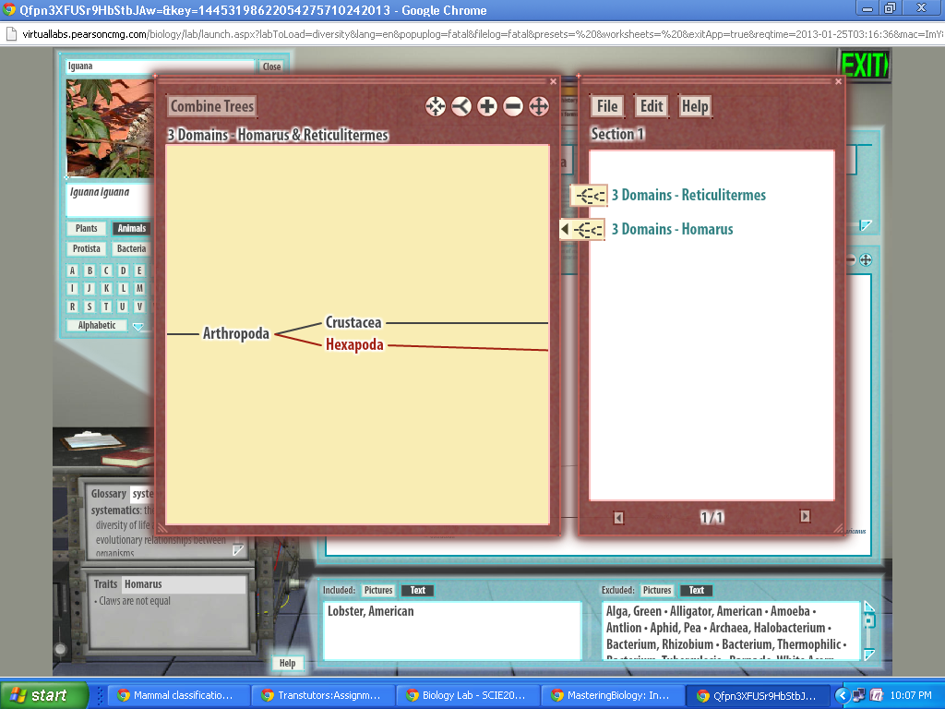
- Locate the main window of the Systematics Lab Room--it is the large white box that shows taxonomic pathways, commonly known as evolutionary trees.

What three taxa appear in the main window when you first enter the Systematics Lab Room? At what level of classification are these three taxa?
Essay answers are limited to about 500 words (3800 characters maximum, including spaces).
3637 Character(s) remaining
SubmitMy AnswersGive Up
Part B
- Locate the Traits box at the lower left of your computer screen. Then, roll over the name Archaea on the main window and notice that information about that selected group appears in the Traits box.
- Click on the term peptidoglycan in the Traits box, and notice that its definition appears in the Glossary box directly above the Traits box.
- Roll over the other two names in the main window to find out about their traits. Click on any unfamiliar terms to learn their definitions.
List one trait for each of these three taxa that distinguishes it from the others.
Essay answers are limited to about 500 words (3800 characters maximum, including spaces).
3665 Character(s) remaining
SubmitMy AnswersGive Up
Part C
- Click on the name Eukarya in the main window. Notice the two boxes below the main window that are titled “Included” and “Excluded.” The information in these boxes indicates which species are included and which are excluded from the group you selected. You can select either Pictures or Text as a way to view the included and excluded species.
Which of these organisms are included in Eukarya? Select all that apply.
Which of these organisms are included in Eukarya? Select all that apply.
yeast
ponderosa pine
E. coli
C. elegans
SubmitMy AnswersGive Up
Part D
- When you clicked on Eukarya in the main window, the names of the five supergroups of eukaryotes appeared, reflecting one current hypothesis of eukaryote evolution. Click on Unikonta, which is the supergroup that includes animals.
- Continue to click on the groups in this sequence until you get to the phylum Chordata:
Opisthokonta > Metazoa > Eumetazoa > Bilateria > Deuterostomia > Chordata
- Using the Included and Excluded boxes beneath the main window, use a trial-and-error approach to click through the groups under phylum Chordata until you’ve found classes Mammalia and Reptilia.
What groups did you click through to get to classes Mammalia and Reptilia?
Essay answers are limited to about 500 words (3800 characters maximum, including spaces).
3644 Character(s) remaining
SubmitMy AnswersGive Up
Part E
- Click on Mammalia. Use the Included box to identify some animals included in this class.
- Now, click on Reptilia and use the Included box to identify some animals included in this class.
Which two of the following species are more closely related: red-eared slider, vampire bat, American alligator?
Essay answers are limited to about 500 words (3800 characters maximum, including spaces).
3710 Character(s) remaining
SubmitMy AnswersGive Up
Part F
- Click on class Reptilia, and continue to click on the groups in this sequence until you get to the order Saurischia:
Diapsida > Archosauria > Dinosauria > Saurischia
- Now, click through the different branches contained within Saurischia.
Are all of the saurischians extinct? Explain.
Essay answers are limited to about 500 words (3800 characters maximum, including spaces).
3710 Character(s) remaining
SubmitMy AnswersGive Up
Part G
Here’s how you can use the Lab Book to examine multiple branches of a tree at the same time.
- Drag the tree in the main window to the right until you get back to where you had selected Deuterostomia in step 7.
- Now, instead of Deuterostomia, click on Ecdysozoa. Then, click on these taxa in this sequence:
Arthropoda > Hexapoda > Insecta > Isoptera > Rhinotermitidae > Reticulitermes
What is the common name of the species you have arrived at?
Essay answers are limited to about 500 words (3800 characters maximum, including spaces).
3745 Character(s) remaining
SubmitMy AnswersGive Up
Part H
- Click the Save button located above the left side of the main window. This will save this view of this particular branch of this tree to the Lab Book. You can save as many opened branches to the Lab Book as you like, and they will remain saved until you exit the lab room or close your Internet browser window.
- Now, drag the tree window back to where you had selected Arthropoda in step 14. This time, click through these taxa in this sequence:
Arthropoda > Crustacea > Malacostraca > Decapoda > Nephropidae > Homarus
What is the common name of the species you have arrived at?
Essay answers are limited to about 500 words (3800 characters maximum, including spaces).
3737 Character(s) remaining
SubmitMy AnswersGive Up
Part I
- Click the Save button to save this branch to the Lab Book.
- Now, click on the red Lab Book next to the clipboard on the lab bench. Open either of the trees you saved by clicking on the tree icon in front of its title.
- On the left-hand page where the opened tree appears, right-click (or Ctrl-click) on the tree, and select Copy Data.
- Next, open the other tree, and then right-click (or Ctrl-click) on the left-hand page. Select Paste Data. Using the scroll bar, you should see the two trees, one above the other.
- Select both trees by command- or Ctrl-clicking on both. Then, click Combine Trees in the upper left corner of the Lab Book. The two trees will merge so that the point at which their lineages diverged is more obvious.
What is the name and level of the taxon where the two species’ lineages diverge?
Essay answers are limited to about 500 words (3800 characters maximum, including spaces).
3757 Character(s) remaining
SubmitMy AnswersGive Up
Part J - Think It Over
In one sentence, summarize how these two species are related and what distinguishes them taxonomically.
Essay answers are limited to about 500 words (3800 characters maximum, including spaces).
3579 Character(s) remaining
SubmitMy AnswersGive Up

