To run Regression please see the following screenshots (obviously you would need to have entered all the data in Excel first before you are ready to run Regression):

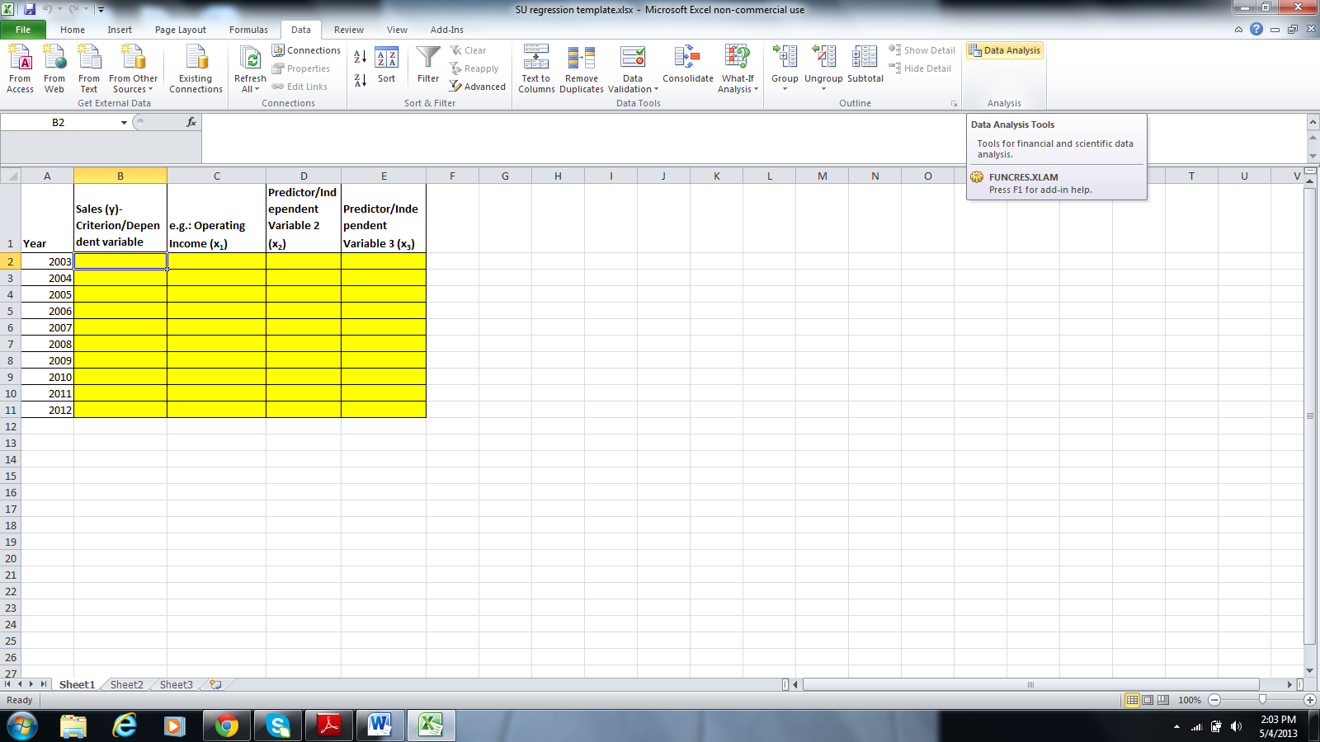

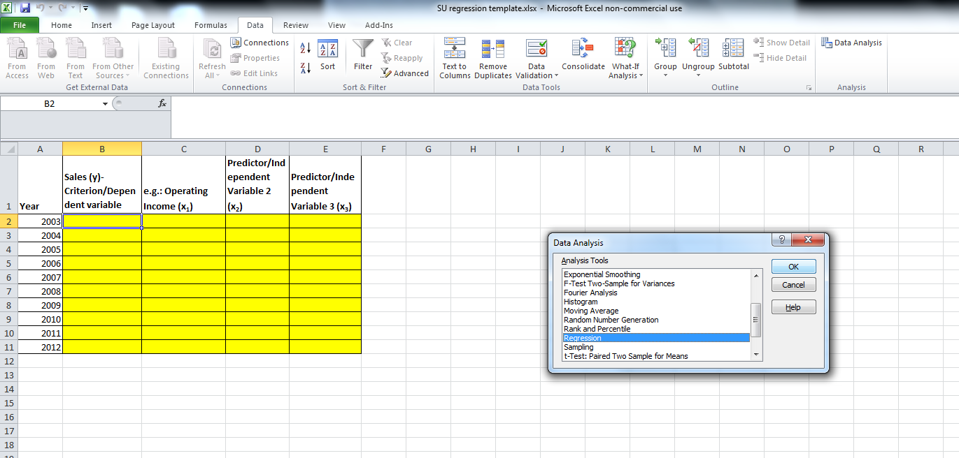

In the below snapshot, I want to run a simple regression between Sales (y) and Operating Income (x)- Note the regression settings below
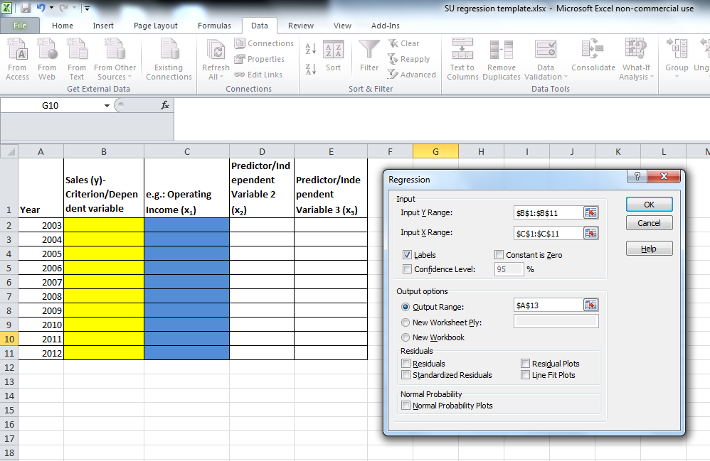

In the snapshot below, I am running a multiple Regression between Sales and all 3 x variables- Note the regression settings below
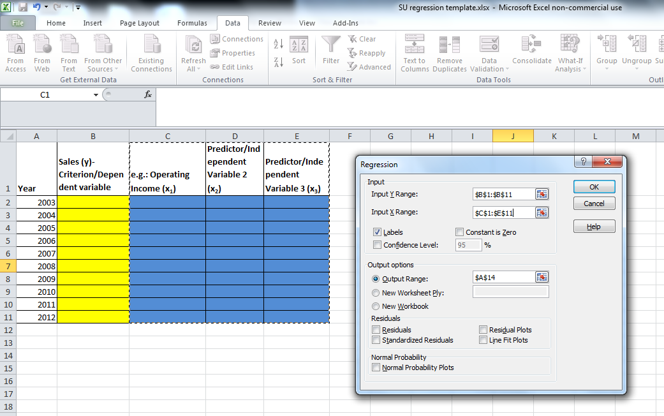

SAMPLE SCREEN SHOT OF REGRESSION OUTPUT
MULTIPLE REGRESSION EXCEL OUTPUT
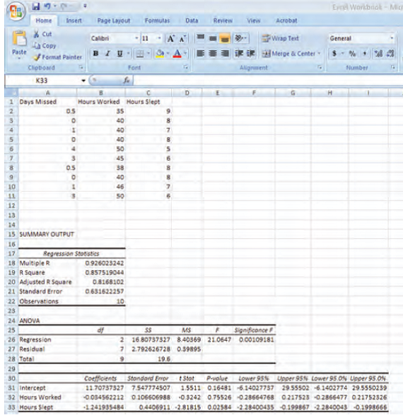
Above is SAMPLE screen shot with “Hours worked” and “Hours slept” are the predictor (x) variables, similar to 3 variables you will be picking data for. “Days missed” is the criterion (y) variable.
The Excel output contains very critical information for a Multiple Regression conducted.

Cells B18- Multiple R, indicates the value of Correlation whether is Multiple or Simple correlation.
Cells B190 R square contains the value of fit, it is expressed as % basis…so in the above example 0.8575 is 85.75%...The fit of an equation ranges from 0 to 1…1 being the best fit

Cell F26- indicates the value of significance…if the value is less than 0.05, then the correlation is significant. In the above case, the correlation is significant
Cells E32 –p values- significance for ““Hours worked”- if it is less than 0.05, then the correlation is significant, for that variable Hours worked
Cell E33- same as above, except for “Hours slept”
(in your assignment, you will have one more variable)

