Question 1
Figure 7.1
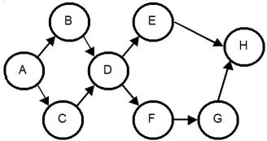
Use the information in Figure 7.1. What are the required predecessors of activity H?
Question 1 options:
E & G.
A through F, including E.
Activity H has no required predecessors.
D.

Question 2
What is the definition of "theoretical maximum efficiency"?
Question 2 options:
It is the amount by which efficiency falls short of 100 percent.
It is the efficiency that could be obtained by a solution that achieves the theoretical minimum number of stations.
It is the maximum time allowed for work on a unit at each station.
It is alternatively called the desired output rate.

Question 3
Which one of the following statements about line balancing is best?
Question 3 options:
If a precedence relationship exists between A and B, they cannot be assigned to the same station.
If the desired output rate increases, the cycle time also tends to increase.
The theoretical minimum number of stations can never be achieved, hence the name "theoretical."
If a line's balance delay is minimized, its efficiency is maximized.

Question 4
Immediate predecessors are the smallest units of work that can be performed independently.
Question 4 options:
True
False

Question 5
Figure 7.1
Use the information in Figure 7.1. If each task has a work time of one minute, what is the theoretical minimum cycle time?
Question 5 options:
There is no minimum cycle time.
1 minute.
8 minutes.
The cycle time cannot be determined with the information given.

Question 6
Line balancing is the assignment of work to stations in a line to achieve the desired output rate with the smallest number of workstations.
Question 6 options:
True
False

Question 7
Figure 7.1
Use the information in Figure 7.1. If each task has a work time of one minute and there are 480 work minutes in a day, what is the task assignment at the fourth workstation if maximum output is desired?
Question 7 options:
A
B
C
D

Question 8
To generate the maximum output, the cycle time should be set as the longest elemental task time.
Question 8 options:
True
False

Question 9
The balance delay is the amount by which efficiency falls short of 100 percent.
Question 9 options:
True
False

Question 10
Line balancing strives to create workstations so that the capacity utilization for the bottleneck is much higher than for the other workstations in the line.
Question 10 options:
True
False

Question 11
Line balancing applies only to line processes that do assembly work, or to work that can be bundled in many ways to create the jobs for each workstation in the line.
Question 11 options:
True
False

Question 12
Balance delay could be described as the:
Question 12 options:
amount by which efficiency falls short of 100 percent.
efficiency that could be obtained by a solution that achieves the theoretical minimum number of stations.
maximum time allowed for work on a unit at each station.
desired output rate.

Question 13
The Theory of Constraints method is also referred to as the drum-buffer-rope method.
Question 13 options:
True
False

Question 14
Which one of the following statements is best concerning line balancing?
Question 14 options:
The theoretical minimum number of stations must always be fewer than the actual number achieved in a final solution. Increasing the output rate may increase the theoretical minimum number of stations.
The "largest number of followers" rule assigns as quickly as possible those work elements most difficult to fit into a station.
Selecting the cycle time can never have an effect on line efficiency.

Question 15
A line balance that is 100% efficient must:
Question 15 options:
be using the minimum cycle time.
be using the theoretical minimum number of work stations.
also achieve 100% balance delay.
be producing the theoretical maximum output.

Question 16
Table 7.13
The following information is given about an assembly line. The desired output rate is 90 units per hour.
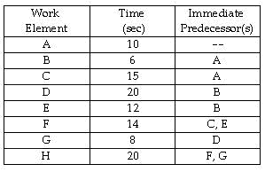
Use the information in Table 7.13. What is the fewest number of workstations that you need?
Question 16 options:
two stations
three stations
four stations
more than four stations

Question 17
Table 7.9
Balance the following line for an output rate of 3 units per minute.
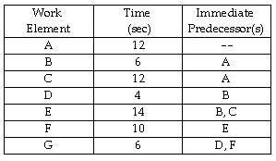
Use the information in Table 7.9. How many stations are required?
Question 17 options:
3
4
5
6

Question 18
Table 7.11
The Pennsylvania Appliance Company is installing an assembly line to produce vacuum cleaners, and you, as an operations manager, are responsible for balancing the line. The work elements to be performed are listed, along with their times and immediate predecessors.
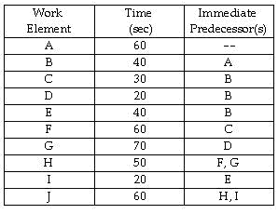
Use the information in Table 7.11. The company is planning to operate 2 shifts per day, 8 hours per shift. If the desired output rate of the line is 480 units per day, what is the cycle time?
Question 18 options:
60 seconds
120 seconds
180 seconds
240 seconds

Question 19
The production of a particular product consists of the following work elements. If the cycle time is 4 minutes and the work-element times are as follows, what is the theoretical minimum number of stations?
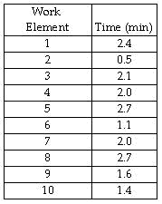
Question 19 options:
fewer than or equal to three stations
four stations
five stations
more than five stations

Question 20
A line-balancing solution has been developed for the assembly line for fertilizer spreaders at Green Grass, Inc. The desired output rate of 30 spreaders per hour will be achieved. The sum of times for all tasks performed on the line is 1200 seconds for each spreader assembled. This is the total productive time. Which of the following statements must be true?
Question 20 options:
The cycle time is 30 seconds per spreader.
The theoretical minimum number of stations is 10.
If the solution calls for 11 stations, the efficiency is 80%.
If the solution calls for 12 stations, the efficiency is 80%.
Save

