Case 1.3:

Along with other policy-analytic methods discussed earlier in this chapter ([Figure 1.1](https://jigsaw.vitalsource.com/books/9781317344834/epub/OEBPS/008a_9781315663012_chapter1.html#fig1_1)), the *influence diagram* and *decision tree are* useful tools for structuring policy problems.[52](https://jigsaw.vitalsource.com/books/9781317344834/epub/OEBPS/008a_9781315663012_chapter1.html#fn-fnref1_52) The influence diagram ([Figure C1.3](https://jigsaw.vitalsource.com/books/9781317344834/epub/OEBPS/008a_9781315663012_chapter1.html#figC1_3)) displays the policy, the National Maximum Speed Limit, as a rectangle. A rectangle always refers to a policy choice or decision node, which in this case is the choice between adopting and not adopting the national maximum speed limit of 55 mph. To the right and above the decision node are uncertain events, represented as ovals, which are connected to the decision node with arrows showing how the speed limit affects or is affected by them. The rectangles with shaved corners represent valued policy outcomes or objectives. The objectives are to lower fuel consumption, reduce travel time, reduce injuries, and avert traffic fatalities. To the right of the objectives is another shaved rectangle, which designates the net benefits (benefits less costs) of the four objectives. The surprising result of using the influence diagram for problem structuring is the discovery of causally relevant economic events, such as the recession and unemployment, which affect miles driven, which in turn affect all four objectives. The “root cause” appears to be the OPEC oil embargo.

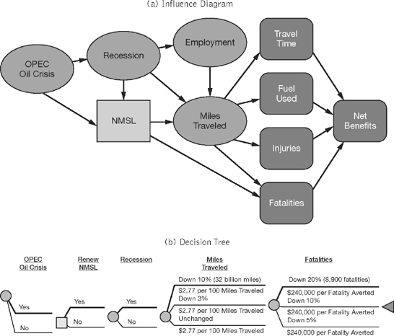

The decision tree is another representation of the influence diagram. Whereas the influence diagram shows how policy choices and uncertain events affect the achievement of objectives, the decision tree displays the monetary value of these objectives. In this abridged and simplified decision tree, there are two branches that represent the alternatives but also the OPEC oil embargo, the recession, the costs of miles traveled, and the dollar benefits of reducing fatalities. The bolded branches show the events with the greatest likelihood of occurring or that already have occurred.