Information to support Week 5 assignment on Case 20.
Table 1 – Industry Attractiveness Assessment for Walt Disney Company’s Businesses

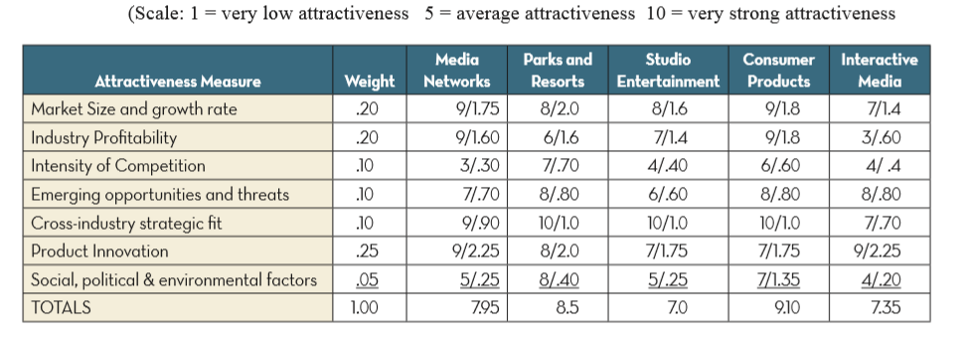
Table 2 – Competitive Position/Business Strength Calculations for Walt Disney Compnay’s Business Units
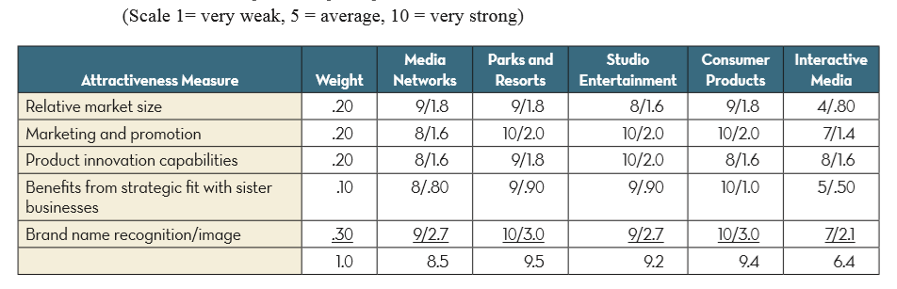

The data from these tables will be the source for the 9-cell matrix. Using business strength on the x-axis and industry attractiveness on the y-axis.

