Overview
- Create the loan amortization schedule
- Create the depreciation schedule.
- Create the schedule that combines interest expenses and depreciation expenses.
- Create a schedule that converts the interest expense and depreciation expense to aftertax dollars
- Create a schedule that shows the aftertax cash out flows…see information below.

Create and loan amortization schedule in Excel spreadsheet – determine how each of the amounts in the table are obtained, calculate them and fill them in for all 360 payments. Note the table shows only the figures for the first two payments and the last two payments; calculate the amounts for the remaining payments and fill them in.

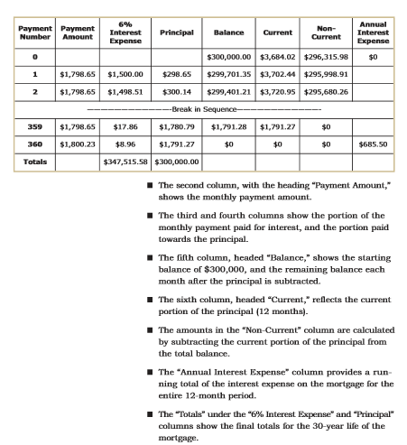

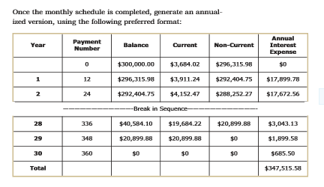

Create a depreciation Schedule

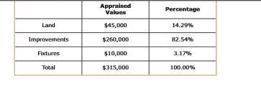
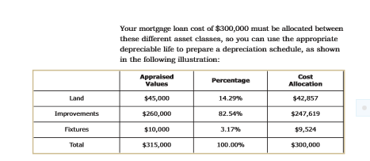

Now you’ll need to use the MACRS table to determine the amount of depreciation expense. Assume the improvements represent 39 –year nonresidential rental property and the figures represent 7- year property.

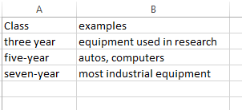
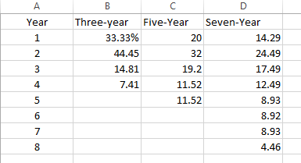

Create annual measures and a source document for annual financial statement. Use the table below for the 39 year nonresidential real property.
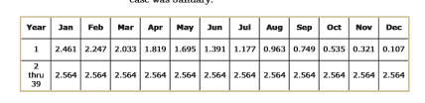

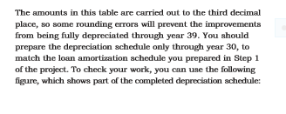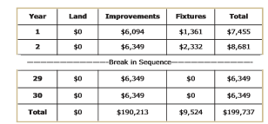

Create a Schedule combining interest expenses and depreciation expenses.
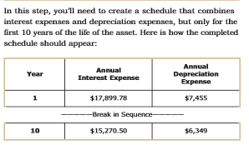

Convert the interest expense and depreciation expense
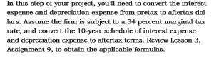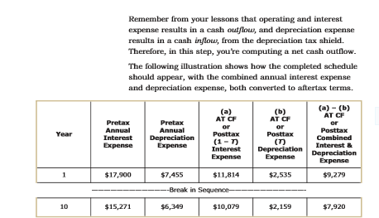

Calculate the aftertax cash outflows
